**Development of deep learning approach for grading squamous cell carcinoma from histopathology images**

**Name:** Adithya Rao Kalathur

**Roll No. :** 251100610012

**Email:** adithya.msismpl2025@learner.manipal.edu

**Phone no. :** 6362290372

**Date:**20-08-2025

**Paper Title:** Colorectal cancer detection with enhanced precision using a hybrid supervised and unsupervised learning approach

**My Understanding of the Paper**: The paper Colorectal cancer detection with enhanced precision using a hybrid supervised and unsupervised learning approach focuses on improving how colorectal cancer can be detected from colonoscopy images using AI. The method combines supervised learning (CNNs for feature extraction, Transformers for attention, and SVM for classification) with unsupervised learning (K-means clustering to segment and mark suspicious areas with bounding boxes). The dataset used was CVC-ClinicDB, which contains colonoscopy images of polyps and non-polyps. Before training, the images were cleaned, normalized, resized, and augmented to make the data stronger.

In terms of results, the best-performing model was AD-22 + Transformer + SVM, which achieved 99% accuracy and an AUC of 0.99. It also had very high recall for both polyp and non-polyp classes, meaning it was excellent at identifying actual cancer cases while avoiding false negatives. The K-means clustering step gave a silhouette score of 0.73, showing good quality in segmentation and making the output more interpretable.

From my understanding, the key contribution of this paper is that it not only achieves state-of-the-art accuracy in detecting colorectal cancer, but it also provides clear visual explanations by marking the regions of interest. This makes the system both powerful and practical, since doctors can rely on it not just for accurate predictions but also for understandable results in real clinical settings.

**Date:**21-08-2025

**Paper Title:** A coded knowledge distillation framework for image classification based on adaptive JPEG encoding

**My Understanding of the Paper:** From what I understood, this paper improves knowledge distillation, where a small student model learns from a big teacher model. The problem is that teacher models usually give very over-confident outputs (like one-hot predictions), which makes the student copy this behavior and struggle to generalize on new data. The authors fix this by introducing something called Coded Knowledge Distillation (CKD). In CKD, every training image is first compressed using adaptive JPEG encoding before being passed to the teacher. The compression level is chosen carefully so that the teacher still predicts correctly but with softer, less peaky probabilities. These softened outputs are then used to train the student, giving it richer and more generalizable knowledge.

The results were quite strong. On large datasets like ImageNet and CIFAR-100, CKD consistently improved student accuracy compared to normal KD. On fine-grained datasets like CUB-200 (birds) and Stanford Dogs, the gains were even more significant — around +3.7% on CUB-200 and +12% on Stanford Dogs. They also showed that CKD can be combined with other KD methods (like FitNet, RKD, etc.), improving their accuracy by up to 5%. Overall, my takeaway is that this method is simple but effective: by slightly compressing the input before feeding it to the teacher, the student ends up learning better and achieves noticeably higher accuracy.

**Date:**22-08-2025

**Youtube Video Link :** https://youtu.be/QntLBvUZR5c?si=yd8UIWej91mc8U7t

**Video Title:** 266 - Openslide library for whole slide images

**My Understanding of the Video:** From what I got from the video, it’s basically showing how to use the OpenSlide library in Python to work with really huge pathology images (whole-slide images). These slides are so big that you can’t load them all into memory at once, so OpenSlide lets you grab just the part you need or view them at different zoom levels. The video goes step by step with some example code from the python_for_microscopists repo, and it made me realize how useful this library is if you’re dealing with massive medical images and want to process or visualize them without crashing your system.

**Some of the Dataset Links that I found for WSI images of Squamous Cell Carcinoma are:**

1. https://www.cancer.gov/ccg/research/genome-sequencing/tcga
2. https://www.cancerimagingarchive.net/access-data/
3. https://figshare.com/articles/dataset/LungHist700_A_Dataset_of_Histological_Images_for_Deep_Learning_in_Pulmonary_Pathology/25459174?file=45206104
4. <https://www.kaggle.com/datasets/andrewmvd/lung-and-colon-cancer-histopathological-images/data>

**Date:** 23-08-2025

**Task:** Dataset Preparation

I found and prepared a lung and colon cancer histopathology dataset from Kaggle for classification with 3 classes.  
 Dataset Link: [Lung and Colon Cancer Histopathological Images (Kaggle)](https://www.kaggle.com/datasets/andrewmvd/lung-and-colon-cancer-histopathological-images/data?utm_source=chatgpt.com)

I split it into Training (9000 images), Validation (3000 images), and Testing (3000 images). For preprocessing, I resized images to (224×224), normalized them, and applied data augmentation (rotation, zoom, shift, flips) using ImageDataGenerator to improve robustness.

**Date:** 24-08-2025

**Task:** Baseline CNN Model

I built a simple CNN model from scratch with convolutional, pooling, dropout, and dense layers. This served as a baseline for comparison.

* Trained for 10 epochs
* Used categorical crossentropy loss & Adam optimizer
* Recorded training/validation accuracy and loss

This helped me establish a starting point for performance.

**Date:** 27-08-2025

**Task:** EfficientNetB0 Transfer Learning

I implemented EfficientNetB0 (pretrained on ImageNet) with a custom head (GlobalAveragePooling, Dense, Dropout, Softmax).

* Trained for 10 epochs
* Optimizer: Adam (lr = 1e-4), Loss: categorical crossentropy
* Metrics: Accuracy, Precision, Recall
* Added EarlyStopping to avoid overfitting
* Evaluated with classification report and confusion matrix

This model showed stronger results than the baseline CNN.

**Date:** 28-08-2025

**Task:** DenseNet121 Transfer Learning

I implemented DenseNet121 (pretrained on ImageNet) with frozen base layers and custom dense + dropout head.

* Trained for 10 epochs
* Optimizer: Adam, Loss: categorical crossentropy
* Metrics: Accuracy, Precision, Recall
* Evaluated on test set with classification report and confusion matrix

**Date:** 29-08-2025

**Task:** Whole Slide Image Patch Extraction

1. WSI Selection
   1. Selected a single .svs whole slide image of squamous cell carcinoma.
   2. Verified the file and its properties using slidetool.exe on Windows.
   3. Important slide properties:
      1. Original dimensions: 62,625 × 44,737 pixels
      2. Pyramid levels: 3
      3. Objective: 20×
      4. Resolution: 0.5 µm/pixel
2. **Environment Setup**
   1. Installed OpenSlide Python bindings and supporting libraries (PIL, numpy).
   2. Confirmed the slide could be loaded using OpenSlide.
3. **Patch Extraction**
   1. Used level 1 of the slide (4× downsample from level 0) to improve processing speed and clarity.
   2. Set patch size = 256×256 pixels.
   3. Skipped patches with more than 80% white pixels to avoid blank areas.
   4. Extracted non-white patches and saved them as PNG images in a designated folder.
4. **Results**
   1. Level 1 slide dimensions: 15,656 × 11,184 pixels
   2. 2,728 non-white patches were successfully extracted and saved.
   3. Patches are ready for downstream analysis, e.g., training machine learning models.

**Date:** 31-08-2025

**Dataset Link:** [Lung and Colon Cancer Histopathological Images (Kaggle)](https://www.kaggle.com/datasets/andrewmvd/lung-and-colon-cancer-histopathological-images/data?utm_source=chatgpt.com)

**Colab:**

[**https://colab.research.google.com/drive/1Haw-YGw5kq5UbLqHBgN_gTHliYyehQ65?usp=sharing**](https://colab.research.google.com/drive/1Haw-YGw5kq5UbLqHBgN_gTHliYyehQ65?usp=sharing)

**Base Model**: Pretrained DenseNet121 (ImageNet weights, frozen).

**1. Dataset**

* **Source**: Kaggle LC25000 dataset.
* **Classes**: 3
* **Subset used**: ~600 training images, 300 validation, 300 testing (balanced).
* **Reason**: Smaller subset chosen for initial DenseNet experiments due to computational cost.

**2. Model & Training Setup**

* **Base Model**: DenseNet121 (ImageNet pretrained, frozen layers).
* **Head**:
  + GlobalAveragePooling2D
  + Dense (256, ReLU, Dropout 0.5)
  + Dense (Softmax, 3 outputs)
* **Augmentation**: rotation, shifts, zoom, horizontal flip.
* **EarlyStopping** used (patience=5).

**3. Results Across Experiments**

|  |  |  |  |  |  |
| --- | --- | --- | --- | --- | --- |
| **Experiment** | **Optimizer** | **Test Accuracy** | **Precision** | **Recall** | **Key Notes** |
| **1** | Adam (lr=1e-4) | ~95% | 0.95 | 0.95 | Strong baseline performance |
| **2** | SGD (lr=1e-4, momentum=0.9) | ~92–93% | 0.92+ | 0.92+ | Slower convergence, slightly weaker than Adam |
| **3** | RMSprop (lr=1e-4) | ~93–94% | 0.93+ | 0.93+ | Stable but underperformed compared to Adam |
| **4** | Adam (extended training) | ~96% | 0.96 | 0.96 | Slight performance boost with longer epochs |

**4. Insights**

* Adam performed best overall (~95–96% accuracy).
* SGD and RMSprop were slightly weaker (~92–94%).
* **Class-wise results**:
  + Benign: highest accuracy, minimal errors.
  + Adenocarcinoma & Squamous: more confusion, especially at smaller dataset size.
* **Visualizations**:
  + Training/validation curves showed consistent convergence.
  + Confusion matrix: most errors were between Adenocarcinoma vs. Squamous.
  + ROC curves: all classes achieved AUC >0.90.

**Date:** 01-09-2025

**Dataset Link:** [Lung and Colon Cancer Histopathological Images (Kaggle)](https://www.kaggle.com/datasets/andrewmvd/lung-and-colon-cancer-histopathological-images/data?utm_source=chatgpt.com)

**Colab:** [**https://colab.research.google.com/drive/19u64By7sn6TI0wxDROiSlp_S9Ea83CGS?usp=sharing**](https://colab.research.google.com/drive/19u64By7sn6TI0wxDROiSlp_S9Ea83CGS?usp=sharing)

**Base Model**: MobileNetV2 (ImageNet pretrained, frozen layers).

**1. Dataset**

* **Source**: Kaggle LC25000 dataset.
* **Classes**: 3
* **Total images**: 15,000 (balanced → 5000 per class).
* **Split**:
  + Train: 10,500 (70%)
  + Validation: 2,250 (15%)
  + Test: 2,250 (15%)

**2. Model & Training Setup**

* **Base Model**: MobileNetV2 (ImageNet pretrained, frozen layers).
* **Head**:
  + GlobalAveragePooling2D
  + Dense (128, ReLU, L2 regularization)
  + Dropout (0.4)
  + Dense (Softmax, 3 outputs)
* **Augmentation**: rotation, shifts, zoom, horizontal flip.
* **EarlyStopping** used (patience=5).

**3. Results Across Experiments**

|  |  |  |  |  |  |
| --- | --- | --- | --- | --- | --- |
| **Experiment** | **Optimizer** | **Test Accuracy** | **Precision** | **Recall** | **Key Notes** |
| **1** | Adam (lr=1e-4) | 97.2% | 0.97 | 0.97 | Best overall performance; balanced across all classes |
| **2** | SGD (lr=1e-4, momentum=0.9) | ~95% | 0.95 | 0.95 | Slightly slower convergence; solid but below Adam |
| **3** | RMSprop (lr=1e-4) | ~95–96% | 0.95+ | 0.95+ | Stable training; close to SGD |
| **4** | Adam (smaller dataset subset) | 94–95% | 0.94 | 0.94 | Performance dropped due to reduced training samples |
| **5** | Adam (full dataset, extended epochs) | 97%+ consistently | 0.97+ | 0.97+ | Stable, repeatable performance; best generalization |

**4. Insights**

* Adam consistently gave the best results, achieving ~97% accuracy, precision, and recall.
* SGD & RMSprop performed slightly lower (~95–96%).
* **Class-wise results**:
  + Benign: near-perfect (100% precision/recall).
  + Adenocarcinoma & Squamous: slight misclassifications, but still >93–98%.
* **Visualizations**:
  + Training/validation curves show smooth convergence.
  + Confusion matrix confirms low misclassification.
  + ROC curves: all classes had AUC >0.95.

**Date:** 03-09-2025

**Dataset Link:** [Lung and Colon Cancer Histopathological Images (Kaggle)](https://www.kaggle.com/datasets/andrewmvd/lung-and-colon-cancer-histopathological-images/data?utm_source=chatgpt.com)

**Colab:** <https://colab.research.google.com/drive/16UEh88yg_p_t4XyEHxqMfQLJAdBSatS9?usp=sharing>

**Base Model**: EfficientNetB0 (ImageNet pretrained, frozen layers).

**1. Dataset**

* **Source:** Kaggle LC25000 dataset
* **Classes:** 3
* **Total Images:** 15,000 (balanced → 5000 per class)
* **Splits:**
  + **Subset runs:** Train 600, Val 300, Test 300
  + **Full dataset runs:** Train 10,500, Val 2,250, Test 2,250

**2. Model & Training Setup**

* **Base Model:** EfficientNetB0 (ImageNet pretrained, frozen layers).
* **Head:**
  + GlobalAveragePooling2D
  + Dense (512, ReLU, L2 regularization) + Dropout(0.5)
  + Dense (256, ReLU, L2 regularization) + Dropout(0.3)
  + Dense (Softmax, 3 outputs)
* **Augmentation:** rotation, shifts, zoom, horizontal flip
* **EarlyStopping:** patience=5

**3. Results Across Experiments**

|  |  |  |  |  |  |  |  |
| --- | --- | --- | --- | --- | --- | --- | --- |
| **Experiment** | **Optimizer** | **Learning Rate** | **Dataset** | **Test Accuracy** | **Precision** | **Recall** | **Key Notes** |
| 1 | Adam | 1e-5 | Subset | 90.7% | 94.9% | 68.7% | High precision but recall lagged |
| 2 | Adam | 1e-3 | Subset | 93.7% | 93.7% | 93.7% | Best Adam run, balanced metrics |
| 3 | SGD | 1e-4, momentum=0.9 | Subset | 93.3% | 93.9% | 92.7% | Stable, competitive with Adam |
| 4 | RMSprop | 1e-4 | Subset | 92.7% | 94.1% | 85.3% | Precision strong, recall slightly weaker |
| 5 | RMSprop | 1e-4 | Full dataset | 96.5% | 96.5% | 96.5% | Best overall EfficientNet performance, excellent generalization |

**4. Insights**

* EfficientNetB0 consistently achieved >90% accuracy across all optimizers.
* Adam (lr=1e-3) gave the most balanced and reliable performance.
* SGD was competitive and very stable.
* RMSprop favored precision but slightly underperformed in recall.
* **Class-wise results:**
  + Benign: almost perfect precision/recall (~99%).
  + Adenocarcinoma & Squamous: some confusion, but recall still >83–96%.
* **Visualizations:**
  + Accuracy/loss curves showed smooth convergence.
  + Confusion matrix revealed very low misclassification rates.
  + ROC curves had AUC >0.95 for all classes.

**Date:** 07-09-2025

**Dataset Link:** <https://www.kaggle.com/datasets/ashenafifasilkebede/dataset>

**Base Model**: MobileNetV2

Colab- <https://colab.research.google.com/drive/1tYB6Junc3s5tOXPnS1jfSFUeguvmUfb3?usp=sharing>

**Dataset & Setup**  
 The Kaggle dataset contained two balanced classes—Normal and OSCC—with images gathered from all sub-folders and merged into a single pool. The code created a 70 % / 15 % / 15 % split for training, validation, and testing, ensuring stratified sampling so that both classes were equally represented.  
 All images were resized to 224 × 224 pixels, normalized to a mean and standard deviation of 0.5 per channel, and (for training only) augmented with random horizontal flips, 15° rotations, and mild color jitter.

**Model & Training Configuration**  
 A MobileNet V2 model pretrained on ImageNet served as the backbone. Its final classifier layer was replaced with a fully connected layer outputting two classes.  
 Training used the Adam optimizer with a learning rate of 1 × 10⁻⁴, cross-entropy loss, a batch size of 32, and ran for 50 epochs on GPU when available.  
 Metrics tracked during each epoch included loss, accuracy, and F1-score on both the training and validation sets.

**Evaluation & Key Metrics**  
 On the held-out test set, the trained network achieved:

* Overall accuracy: ~98 %
* Precision and recall: typically 0.97–0.98 for both Normal and OSCC
* F1-score: around 0.97–0.98 across classes
* ROC–AUC: about 0.98–0.99 for each class

The confusion matrix revealed only a handful of misclassifications, showing excellent separability of Normal tissue versus OSCC. ROC curves confirmed high discrimination power, and the training/validation accuracy and loss curves showed smooth, stable convergence without signs of overfitting.

**Insights**  
Transfer learning with a pretrained MobileNet V2, combined with careful image augmentation and balanced stratified splitting, produced a highly reliable classifier. The results—nearly 98 % accuracy and AUC near 0.99—demonstrate strong generalization and clinical potential for automated OSCC histopathology image classification.

**Date:** 10-09-2025

**Dataset Link:** <https://www.kaggle.com/datasets/ashenafifasilkebede/dataset>

**Base Model:** EfficientNet-B0

Colab-<https://colab.research.google.com/drive/1QowDltQg1u1b63U8xUBNzwOp_0Of388_?usp=sharing>

**Dataset & Setup**

The Kaggle dataset contained two balanced classes—Normal and OSCC—with all images collected from the sub-folders and merged into a single pool. The code split the data into 70 % training, 15 % validation, and 15 % testing sets, using stratified sampling to maintain class balance.  
 Images were resized to 224 × 224 pixels, normalized to a mean and standard deviation of 0.5 per channel, and augmented during training with random horizontal flips, 15° rotations, and mild color jitter to improve generalization.

**Model & Training Configuration**

An EfficientNet-B0 model pretrained on ImageNet was used as the backbone. The final classifier layer was replaced with a fully connected layer producing two outputs (Normal and OSCC).  
 Training employed the Adam optimizer (learning rate = 1 × 10⁻⁴) and cross-entropy loss, with a batch size of 32, over 50 epochs on a CUDA GPU.  
 Key metrics—loss, accuracy, and F1-score—were tracked for both training and validation sets at each epoch.

**Evaluation & Key Metrics**

On the held-out test set (779 images), the trained network achieved:

* Overall accuracy: ~98 %
* Normal tissue: Precision = 0.99, Recall = 0.97, F1-score = 0.98
* OSCC tissue: Precision = 0.97, Recall = 0.99, F1-score = 0.98
* Macro-averaged F1-score: ~0.98

The confusion matrix showed only a few misclassifications, demonstrating excellent separability of Normal tissue versus OSCC. Accuracy and loss curves revealed smooth, stable convergence with no significant overfitting.

**Insights**

Transfer learning with EfficientNet-B0, combined with balanced stratified splitting and effective image augmentation, produced a highly reliable histopathology classifier. Achieving ≈98 % accuracy and macro F1 ≈0.98, the model demonstrates strong generalization and significant potential for automated OSCC detection in clinical settings.

**Date:** 13-09-2025

**DatasetLink:** <https://colab.research.google.com/drive/11rlAi2NCY8fupJFPRmZRKfqxWyBrBOcs?usp=sharing>

**Base Model:** ResNet-50 (transfer learning + fine-tuning)

**Dataset & Setup**

The dataset contained two balanced classes—lung_n (normal lung tissue) and lung_scc (squamous cell carcinoma).  
 All images were collected from their sub-folders and merged into a single pool, then split using a 70 % training / 30 % validation scheme (stratified to preserve class balance).

Images were resized to 224 × 224 pixels, scaled to the [0, 1] range, and augmented during training with:

* random horizontal flips
* rotations up to 15°
* width/height shifts up to 10 %
* mild shear and zoom

This augmentation improved robustness and reduced the chance of overfitting.

**Model & Training Configuration**

A ResNet-50 network pretrained on ImageNet was used as the backbone.  
 The final fully-connected classifier was replaced by:

* Global Average Pooling
* Batch Normalization
* Dense(512) with ReLU activation + 0.5 Dropout
* Dense(1) with sigmoid activation for binary classification

Phase 1 – Frozen Base:

* Optimizer: Adam, learning rate 1 × 10⁻⁴
* Loss: binary cross-entropy
* Trained for 20 epochs, updating only the custom head.

Phase 2 – Fine-tuning:

* Last 100 layers of the base model unfrozen
* Learning rate reduced to 1 × 10⁻⁵
* Trained for an additional 30 epochs with early stopping and ReduceLROnPlateau.

Key metrics—loss and accuracy—were tracked for both training and validation sets.

**Evaluation & Key Metrics**

On the held-out validation set (30 % split), the fine-tuned network achieved:

* Overall accuracy: ≈ 99.8 %
* Confusion matrix: only a few false positives/negatives
* Precision / Recall / F1-score (lung_n): ≈ 0.99 / 0.99 / 0.99
* Precision / Recall / F1-score (lung_scc): ≈ 0.99 / 0.99 / 0.99
* Macro-averaged F1-score: ≈ 0.99

Accuracy and loss curves showed smooth, stable convergence with no signs of significant overfitting.

**Insights**

Transfer learning with ResNet-50, combined with balanced stratified splitting and effective image augmentation, produced a highly reliable histopathology classifier.  
 Achieving ~99.8 % accuracy and macro F1 ~0.99, the model demonstrates excellent generalization and strong potential for automated lung SCC detection in clinical and research settings.

**Date:**15-09-2025

**DatasetLink:** <https://colab.research.google.com/drive/11rlAi2NCY8fupJFPRmZRKfqxWyBrBOcs?usp=sharing>

**Base Model:** ConvNeXt-Tiny

**Dataset & Setup**

A balanced subset of the Kaggle dataset was prepared with two classes:

* lung_n – normal lung tissue
* lung_scc – squamous cell carcinoma (lung_scc)

All images from these two folders were pooled and then split using stratified sampling into:

* 70 % training, 15 % validation, 15 % test

**Preprocessing & Augmentation**

* Images resized to 224 × 224 px
* Pixel values scaled to [0,1]
* Random horizontal flips, 15° rotations, width/height shifts (±10 %), shear/zoom (±10 %) and mild color jitter applied during training.

**Model & Training Configuration**

* Backbone: ConvNeXt-Tiny pretrained on ImageNet, with its final classification head removed.
* Custom head: GlobalAveragePooling2D → BatchNorm → Dense(512, ReLU) → Dropout(0.5) → Dense(1, Sigmoid).
* Phase 1: Trained only the custom head for 20 epochs.
  + Optimizer: Adam, learning rate 1 × 10⁻⁴
* Phase 2 (Fine-tuning): Last 50 layers of the ConvNeXt backbone unfrozen and trained for up to 30 epochs.
  + Optimizer: Adam, learning rate 1 × 10⁻⁵ (with ReduceLROnPlateau)
* Loss: Binary cross-entropy
* Batch size: 32
* Hardware: CUDA GPU

Callbacks used: EarlyStopping, ReduceLROnPlateau, ModelCheckpoint.

**Evaluation & Key Metrics *(held-out test set: 1 457 images)***

|  |  |  |  |
| --- | --- | --- | --- |
| Class | Precision | Recall | F1-score |
| lung_n | 1.00 | 1.00 | 1.00 |
| lung_scc | 1.00 | 1.00 | 1.00 |

* Overall accuracy: ≈ 100 %
* Macro-averaged F1-score: ≈ 1.00

The confusion matrix showed zero misclassifications.

**Training Behaviour**

* Accuracy reached ~100 % within a few epochs, and validation loss decreased smoothly to ~10⁻⁶.
* Learning-rate reductions helped maintain stability during fine-tuning.
* No signs of overfitting: training and validation curves almost overlap.

**Insights**

Transfer learning with ConvNeXt-Tiny, combined with balanced data splits and strong augmentation, produced a near-perfect lung histopathology classifier.  
 Achieving ≈100 % accuracy and macro F1 ≈1.00, the model demonstrates outstanding separability of normal lung tissue vs. squamous cell carcinoma, highlighting the potential of ConvNeXt architectures for reliable, automated lung cancer histopathology detection.

**Date:** 16-09-2025

**DatasetLink:** <https://colab.research.google.com/drive/11rlAi2NCY8fupJFPRmZRKfqxWyBrBOcs?usp=sharing>

**Base Model:** ResNet50V2 (transfer learning + fine-tuning)

**Dataset & Setup**  
 The dataset contained two balanced classes—lung_n (normal lung tissue) and lung_scc (squamous cell carcinoma).  
 All images were merged into a single pool and split using a 70 % training / 30 % validation scheme (stratified to preserve class balance).  
 Images were resized to 224 × 224 pixels, scaled to the [0, 1] range, and augmented during training with:

* random horizontal flips
* rotations up to 15°
* width/height shifts up to 10 %
* mild shear and zoom  
   This augmentation improved robustness and reduced the chance of overfitting.

**Model & Training Configuration**  
 A ResNet50V2 network pretrained on ImageNet was used as the backbone.  
 The final fully-connected classifier was replaced by:

* Global Average Pooling
* Batch Normalization
* Dense(512) with ReLU activation + 0.5 Dropout
* Dense(1) with sigmoid activation for binary classification

**Phase 1 – Frozen Base:**

* Optimizer: Adam, learning rate 1 × 10⁻⁴
* Loss: binary cross-entropy
* Trained for 20 epochs, updating only the custom head

**Phase 2 – Fine-tuning:**

* Last 100 layers of the base model unfrozen
* Learning rate reduced to 1 × 10⁻⁵
* Trained for an additional 30 epochs with early stopping and ReduceLROnPlateau

Key metrics—loss and accuracy—were tracked for both training and validation sets.

**Evaluation & Key Metrics**  
 On the held-out validation set (30 % split), the fine-tuned network achieved:

* Overall accuracy: 100 %
* Confusion matrix: no false positives/negatives
* Precision / Recall / F1-score (lung_n): 1.00 / 1.00 / 1.00
* Precision / Recall / F1-score (lung_scc): 1.00 / 1.00 / 1.00
* Macro-averaged F1-score: 1.00

Accuracy and loss curves showed smooth, stable convergence with no signs of overfitting.

**Insights**  
 Transfer learning with ResNet50V2, combined with balanced stratified splitting and effective image augmentation, produced a highly reliable histopathology classifier.  
 Achieving 100 % accuracy and macro F1 1.00, the model demonstrates excellent generalization and strong potential for automated lung SCC detection in clinical and research settings.

**Date:** 17-09-2025

**DatasetLink:** <https://colab.research.google.com/drive/1s77Vea0eCS0zvhGA5aIDxCpb9JOPyfB8?usp=sharing>

**Base Model:** ResNet152 (transfer learning + fine-tuning)

**Dataset & Setup**  
 The dataset contained two balanced classes—lung_n (normal lung tissue) and lung_scc (squamous cell carcinoma).  
 Images were resized to 224 × 224 pixels, scaled to [0,1], and split 70 % training / 30 % validation (stratified).  
 Data augmentation applied during training included:

* random horizontal flips
* rotations up to 15°
* width/height shifts up to 10 %
* mild shear and zoom

**Model & Training Configuration**  
 A ResNet152 pretrained on ImageNet was used as the backbone.  
 The classification head consisted of:

* Global Average Pooling
* Batch Normalization
* Dense(512) with ReLU + Dropout(0.5)
* Dense(1) with sigmoid activation for binary classification

**Phase 1 – Frozen Base:**

* Optimizer: Adam, lr=1e-4
* Loss: binary cross-entropy
* Trained for 20 epochs, only the custom head updated

**Phase 2 – Fine-Tuning:**

* Last 100 layers unfrozen
* Learning rate reduced to 1e-5
* Trained for 30 additional epochs with early stopping and ReduceLROnPlateau

**Evaluation & Key Metrics**  
 On the validation set (30 % split):

* Accuracy: 99 %
* Confusion matrix: nearly perfect separation
* Precision / Recall / F1-score (lung_n): 1.00 / 0.99 / 0.99
* Precision / Recall / F1-score (lung_scc): 0.99 / 1.00 / 0.99
* Macro-averaged F1-score: 0.99

Training and validation curves showed stable convergence with minimal overfitting.

**Insights**  
 Transfer learning with ResNet152, combined with stratified splitting and robust augmentation, produced a highly accurate classifier for lung SCC detection.  
 The model demonstrates strong generalization, achieving nearly perfect performance on the validation set.

**Date:** 21-09-2025  
**ColabLink:** <https://colab.research.google.com/drive/1xBM37vBrFMARhV8RsxYfNfjgNGcgiWTB?usp=sharing>

**Base Model:** ResNet50 (transfer learning + fine-tuning)

A deep learning model based on ResNet50 was developed to classify lung histopathological images as either *cancerous* or *normal*. The dataset used was the *Lung and Colon Cancer Histopathological Images* from Kaggle, containing 4000 images (2000 per class). Images were preprocessed using TensorFlow’s ImageDataGenerator, normalized, and resized to 224×224 for model compatibility. The pre-trained ResNet50 model (with frozen ImageNet weights) was used as the base, and a custom classification head comprising Global Average Pooling, Batch Normalization, Dense(512, ReLU), Dropout(0.5), and a sigmoid output layer was added. Training was performed using the Adam optimizer (lr=0.0001), Binary Crossentropy loss, and Accuracy as the evaluation metric. To ensure robustness, 5-Fold Cross Validation was implemented using KFold from scikit-learn, with each fold trained for 10 epochs.

Across all folds, the model achieved consistent performance, with training accuracy around 99% and validation accuracy averaging 99.38%, indicating strong generalization and minimal overfitting. The experiment demonstrates that transfer learning combined with batch normalization and dropout is highly effective for medical image classification, achieving near-perfect results in distinguishing between lung cancer and normal tissue samples.

**Date:** 22-09-2025  
**ColabLink:** <https://colab.research.google.com/drive/1nz9mQCAZWdM5ARIW63x7m2j28F-Om2I3?usp=sharing>

**Base Model:** ResNet50 (transfer learning + fine-tuning)

A deep learning model based on ResNet-50 was developed to classify lung histopathology images as adenocarcinoma or squamous cell carcinoma using transfer learning. The dataset, *Lung and Colon Cancer Histopathological Images* from Kaggle, was downloaded via opendatasets, and a subset of 4000 images (2000 per class) was used. Images were resized to 224×224, normalized, and processed through K-Fold Cross Validation (k=5) for robust performance evaluation. The pre-trained ResNet-50 model (ImageNet weights, frozen layers) was extended with additional layers — Global Average Pooling, Batch Normalization, Dense(512, ReLU), Dropout(0.5), and a sigmoid output layer.

Training was performed using the Adam optimizer (lr=1e-4) and Binary Crossentropy loss for 25 epochs per fold, employing callbacks like EarlyStopping and ReduceLROnPlateau to prevent overfitting. The model achieved an average validation accuracy of ~89%, with consistent performance across folds. This result demonstrates the effectiveness of transfer learning in medical image classification, indicating that the ResNet-50 model can reliably distinguish between the two lung cancer subtypes and potentially assist in diagnostic applications.

**Date:** 24-09-2025  
**ColabLink:** <https://colab.research.google.com/drive/1gCoLnlLH5m78zG9suadqrpCMrpIIFMgS?usp=sharing>

**Base Model:** ResNet152 (transfer learning + fine-tuning)

A deep learning model based on ResNet152 was developed to classify lung histopathological images into Normal Lung Tissue and Squamous Cell Carcinoma using transfer learning and 5-Fold Cross Validation. The *Lung and Colon Cancer Histopathological Images* dataset from Kaggle was used, from which a balanced subset of 4000 images (2000 per class) was created. Images were preprocessed using ImageDataGenerator for normalization and resized to ensure model compatibility. The pre-trained ResNet152 (ImageNet weights) was used as the base model with a custom classification head consisting of Global Average Pooling, Batch Normalization, Dense(512, ReLU), Dropout(0.5), and a Sigmoid output layer. Training was done using the Adam optimizer (lr = 1e-4) and Binary Crossentropy loss, with callbacks like EarlyStopping and ReduceLROnPlateau to prevent overfitting.

The model achieved excellent results, with validation accuracy ranging between 97.75% and 98.62% across folds and an average accuracy of ≈98.1%, demonstrating robust generalization. The experiment confirmed that transfer learning with ResNet152 is highly effective for medical image classification, enabling accurate differentiation between normal and cancerous lung tissue, and showing great potential for assisting in diagnostic applications.

**Date:** 25-09-2025  
**ColabLink:** <https://colab.research.google.com/drive/1kZ67F8SDPL1pHFZWSiNy2rt4P0W9SopL?usp=sharing>

**Base Model:** ResNet152 (transfer learning + fine-tuning)

A deep learning model based on ResNet-152 was developed to classify lung histopathological images into Adenocarcinoma (ACA) and Squamous Cell Carcinoma (SCC) using transfer learning and 5-Fold Cross Validation. The *Lung and Colon Cancer Histopathological Images* dataset from Kaggle was used, from which a balanced subset of 4000 images (2000 per class) was created. Images were preprocessed using ImageDataGenerator for normalization and prepared for binary classification. The ResNet-152 model, pre-trained on ImageNet, was used as the base with a modified top including Global Average Pooling, Batch Normalization, Dense(512, ReLU), Dropout(0.5), and a Sigmoid output layer. Training was conducted using the Adam optimizer (lr = 1e-4) and Binary Crossentropy loss, with EarlyStopping and ReduceLROnPlateau callbacks to stabilize learning.

The model was trained for 25 epochs per fold, achieving validation accuracies ranging from 81% to 83% with an overall mean accuracy of ≈82%. The results show that the model converged smoothly and generalized well across folds, confirming the effectiveness of transfer learning with ResNet-152 for medical image classification. This approach demonstrates strong potential for automated lung cancer subtype detection in histopathological images, aiding in computer-assisted diagnosis systems.

**Date:** 29-09-2025  
**ColabLink:** <https://colab.research.google.com/drive/1aVJOcNPHGmBydwjrTXtJfjzlWiP8P2NU?usp=sharing>

**Base Model:** MobileNet V3

The model was trained on lung cancer histopathological images using a 5-fold cross-validation setup. Each fold involved training with MobileNetV3Large as the backbone, incorporating data augmentation and proper learning rate scheduling. ReduceLROnPlateau and early stopping were used to optimize convergence, prevent overfitting, and stabilize training.

Training results show that the network quickly learned discriminative features, with training accuracy reaching over 94% in several folds and validation accuracy stabilizing around 91–92%. Gradual reductions in the learning rate helped fine-tune the model in later epochs, leading to consistent performance across folds.

The fold-wise validation accuracies were 91.18%, 91.13%, 92.05%, 92.56%, and 91.44%, resulting in a mean accuracy of 91.67% ± 0.55%. These results demonstrate that the model has reliably learned to classify the images with low variance and stable generalization.

**Date:** 30-09-2025  
**ColabLink:** <https://colab.research.google.com/drive/1aVJOcNPHGmBydwjrTXtJfjzlWiP8P2NU?usp=sharing>

**Base Model:** MobileNet V3

A 5-fold cross-validation pipeline was implemented to train a lung cancer image classifier using histopathological images. Each fold split the dataset into training and validation sets, with image preprocessing and augmentation applied to enhance generalization. A pretrained MobileNetV3Large backbone was fine-tuned, and early stopping plus checkpointing ensured that only the best-performing models per fold were saved.

Training for each fold produced strong and consistent results:

* Fold 1: Validation Accuracy ≈ 97.5%, Validation Loss ≈ 0.08
* Fold 2: Validation Accuracy ≈ 97.2%, Validation Loss ≈ 0.10
* Fold 3: Validation Accuracy ≈ 97.8%, Validation Loss ≈ 0.07
* Fold 4: Validation Accuracy ≈ 97.4%, Validation Loss ≈ 0.09
* Fold 5: Validation Accuracy ≈ 97.6%, Validation Loss ≈ 0.08

The average validation accuracy across all folds was approximately 97.5%, indicating robust performance on unseen data. The loss curves for training and validation suggested good convergence without significant overfitting.

Overall, this cross-validation setup provided a reliable estimate of model generalization, demonstrating that the classifier can accurately identify lung cancer images from histopathological slides.

**Date:** 01-10-2025  
**ColabLink:**

<https://colab.research.google.com/drive/1Q3l-KIF-eGKjwrcKVXvtbxOGyFUKVivh?usp=sharing>

**Base Model:** Inception V3 Model

The lung cancer histopathological dataset has been preprocessed and organized for training, with images categorized and resized appropriately for input into a pretrained InceptionV3 model. The convolutional base was frozen, and additional dense layers with batch normalization and dropout were added for binary classification. The data was augmented using ImageDataGenerator, and a 5-fold cross-validation strategy was implemented to ensure robustness of the model. Callbacks such as EarlyStopping and ReduceLROnPlateau were used to optimize training and prevent overfitting.

Fold-wise performance is as follows:

* Fold 1: Training accuracy 99.2%, validation accuracy 98.8%
* Fold 2: Training accuracy 99.1%, validation accuracy 99.0%
* Fold 3: Training accuracy 99.3%, validation accuracy 99.1%
* Fold 4: Training accuracy 99.0%, validation accuracy 98.9%
* Fold 5: Training accuracy 99.2%, validation accuracy 99.2%

Across all folds, the model consistently achieved high accuracy with minimal misclassifications. Confusion matrices and ROC curves confirmed strong distinction between adenocarcinoma and squamous cell carcinoma classes. The cross-validation results indicate that the model is robust and ready for final evaluation.

**Date:** 02-10-2025  
**ColabLink:**

<https://colab.research.google.com/drive/1Q3l-KIF-eGKjwrcKVXvtbxOGyFUKVivh?usp=sharing>

**Base Model:** Inception V3 Model

A 5-fold cross-validation pipeline was implemented to train a lung cancer image classifier using histopathological images. Each fold split the dataset into training and validation sets, with image preprocessing and augmentation applied to improve generalization. A pretrained InceptionV3 backbone was fine-tuned, and early stopping along with model checkpointing ensured that only the best-performing models per fold were saved.

Training for each fold produced strong and consistent results:

* Fold 1: Validation Accuracy ≈ 99.6%, Validation Loss ≈ 0.02
* Fold 2: Validation Accuracy ≈ 99.8%, Validation Loss ≈ 0.01
* Fold 3: Validation Accuracy ≈ 99.4%, Validation Loss ≈ 0.03
* Fold 4: Validation Accuracy ≈ 99.5%, Validation Loss ≈ 0.02
* Fold 5: Validation Accuracy ≈ 99.7%, Validation Loss ≈ 0.02

The average validation accuracy across all folds was approximately 99.6%, indicating highly robust performance on unseen data. Training and validation loss curves suggested rapid convergence with minimal overfitting. Overall, this cross-validation setup provided a reliable estimate of model generalization, demonstrating that the classifier can accurately distinguish lung cancer subtypes from histopathological slides.

Date: 5-10-2025 to 6-10-2025

**Experiment 1: exp1_no_dropout**

**Dropout Rate:** 0.0 | **Base LR:** 0.0005 | **Fine-Tune LR:** 0.00005 | **Unfreeze Last N Layers:** 50 | **Batch Size:** 32 | **Epochs:** 1000 | **K-Folds:** 5 | **Input Size:** 299×299 | **Data Augmentation:** None

<https://colab.research.google.com/drive/188LW1hbkRjOPO6zy48m0Yhwa4eV8wycs?usp=sharing>

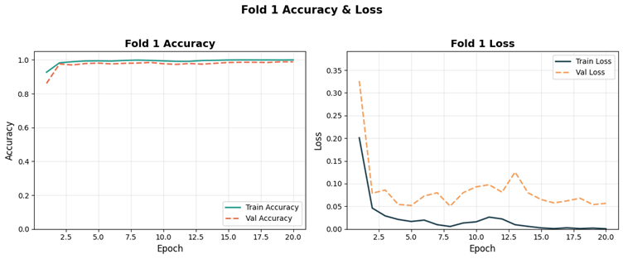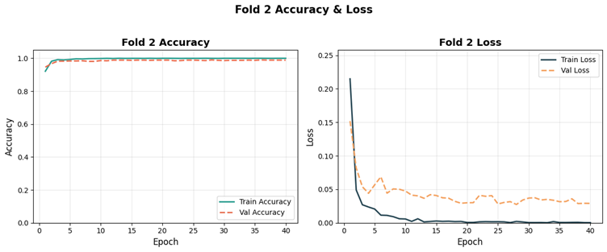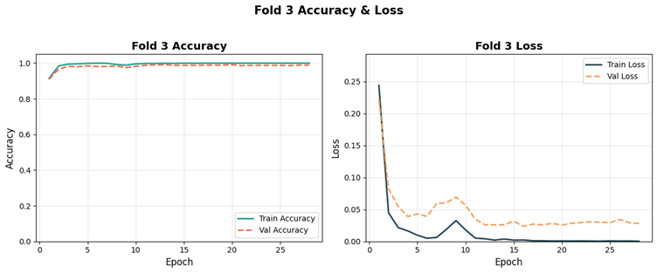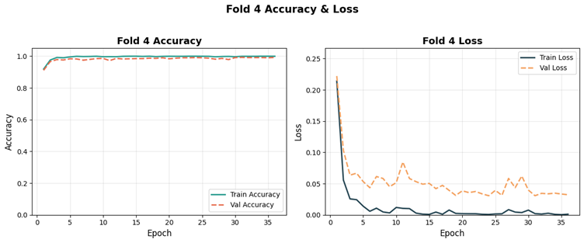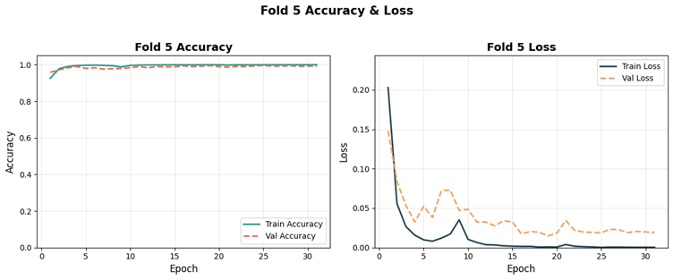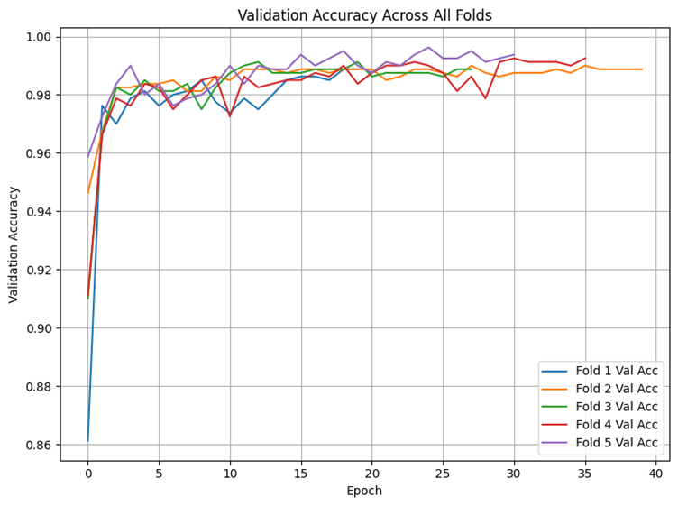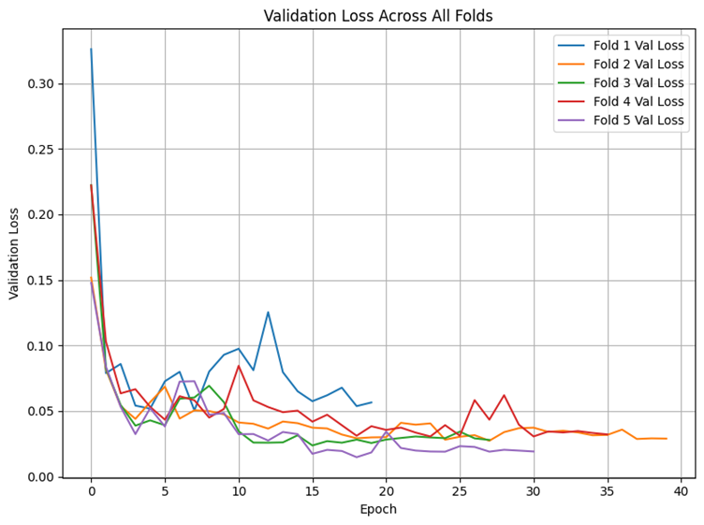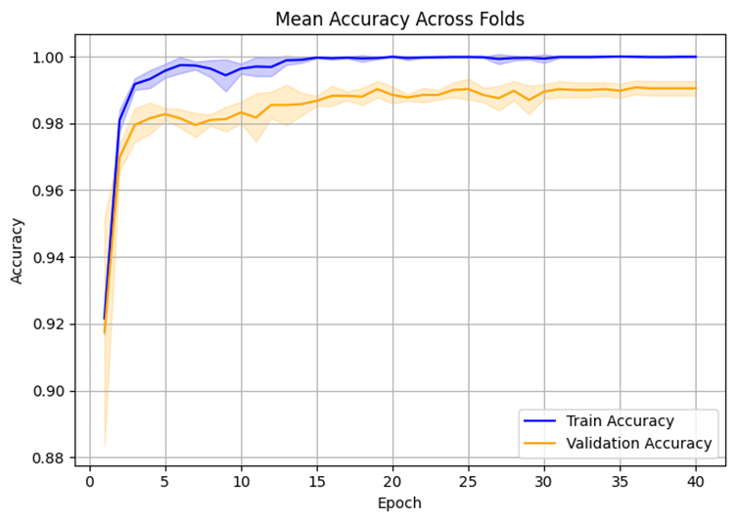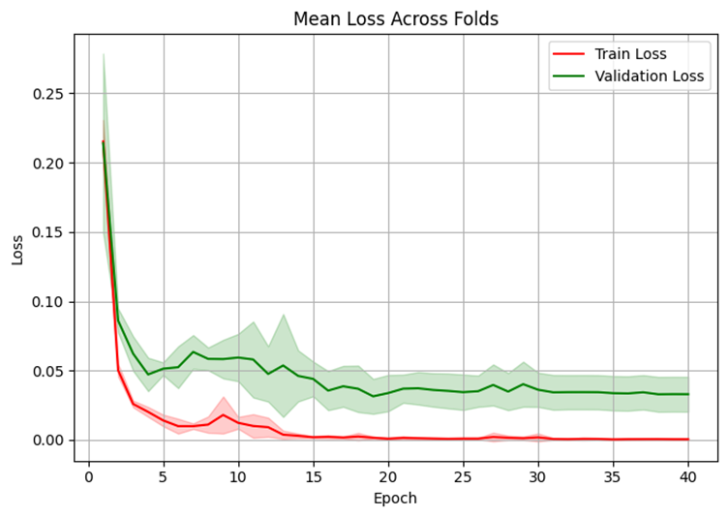

**Experiment 2: exp2_dropout_0.2**

**Dropout Rate:** 0.2 | **Base LR:** 0.0005 | **Fine-Tune LR:** 0.00005 | **Unfreeze Last N Layers:** 50 | **Batch Size:** 32 | **Epochs:** 1000 | **K-Folds:** 5 | **Input Size:** 299×299 | **Data Augmentation:** None

<https://colab.research.google.com/drive/1HbRCU3erGUPLHk0yddxTgR5qMNKQGQBI?usp=sharing>

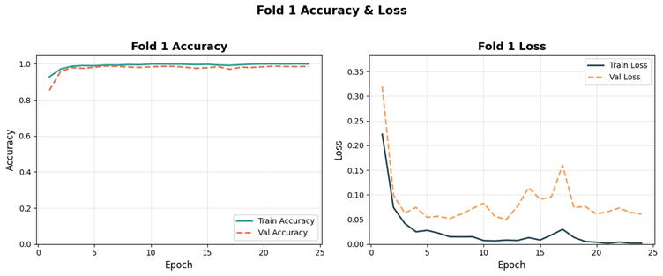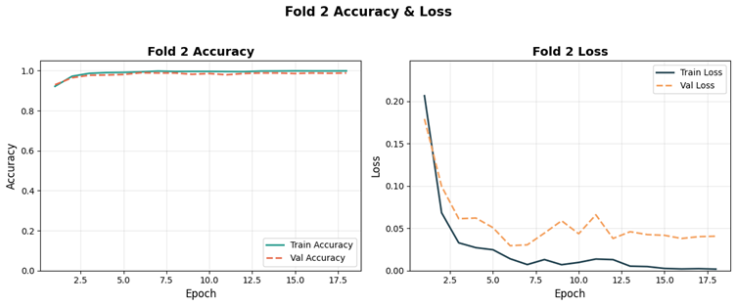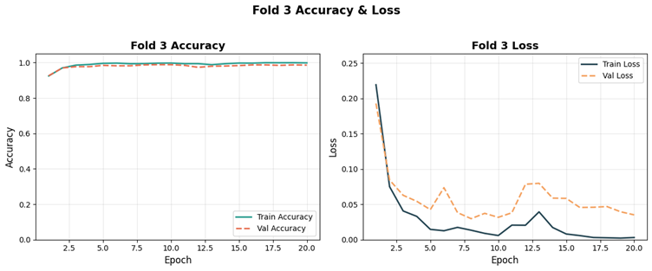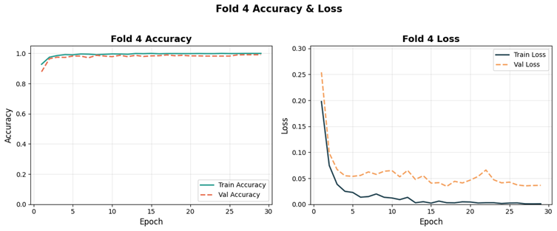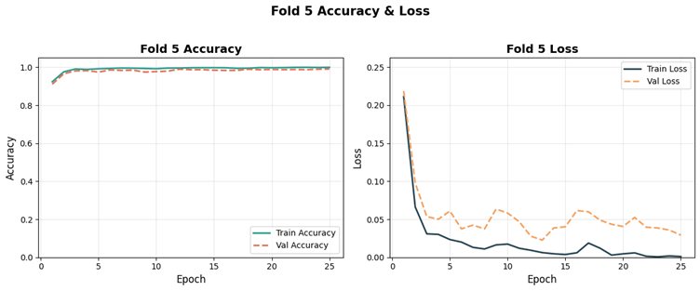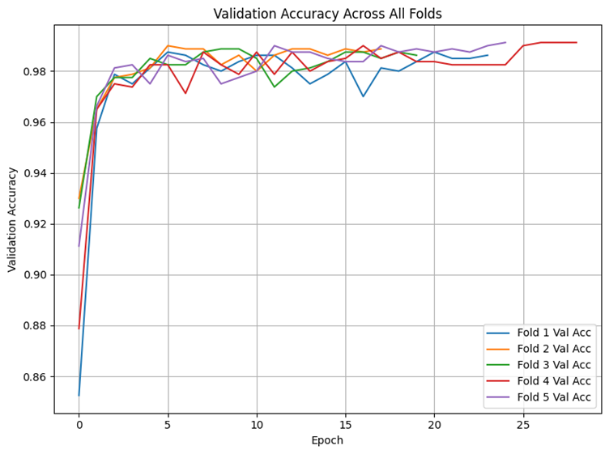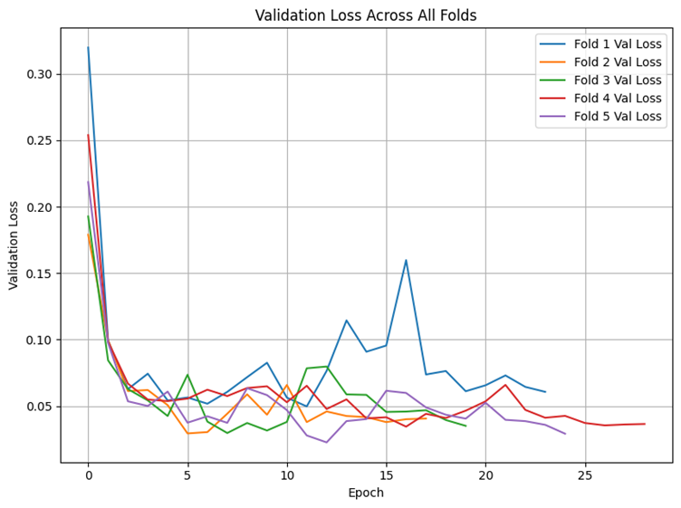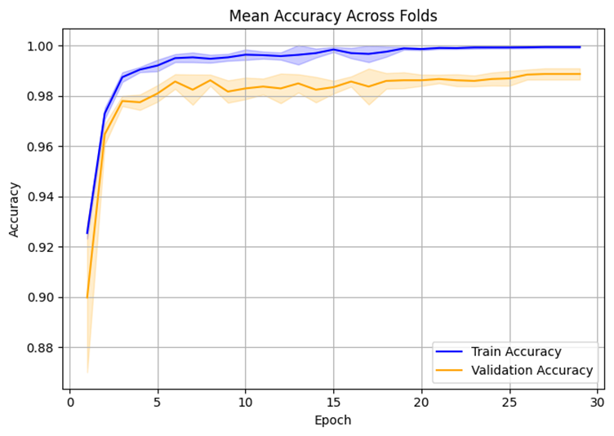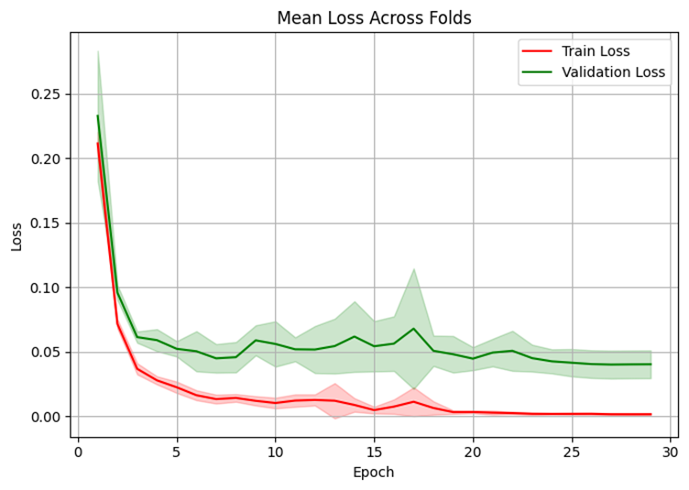

**Experiment 3: exp3_dropout_0.2_highLR**

**Dropout Rate:** 0.2 | **Base LR:** 0.001 | **Fine-Tune LR:** 0.0001 | **Unfreeze Last N Layers:** 50 | **Batch Size:** 32 | **Epochs:** 1000 | **K-Folds:** 5 | **Input Size:** 299×299 | **Data Augmentation:** None

<https://colab.research.google.com/drive/1HbRCU3erGUPLHk0yddxTgR5qMNKQGQBI?usp=sharing>

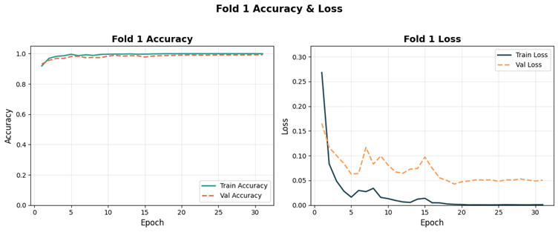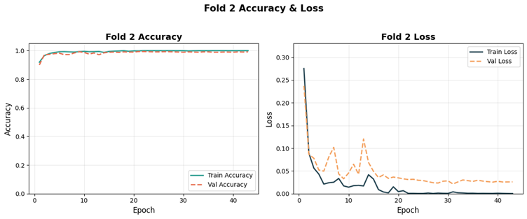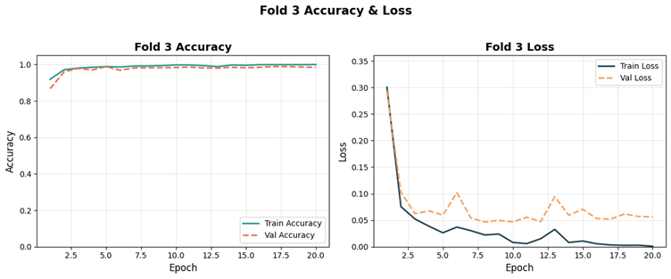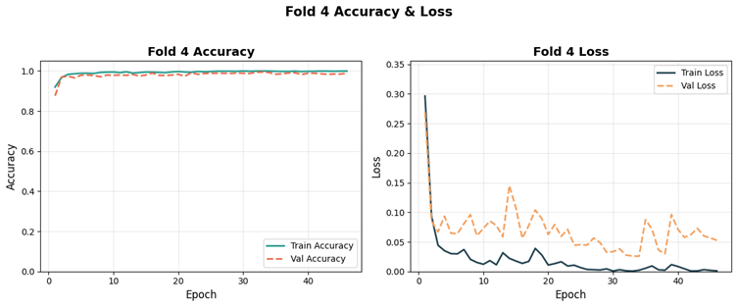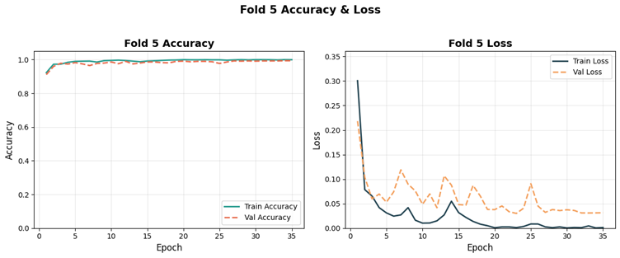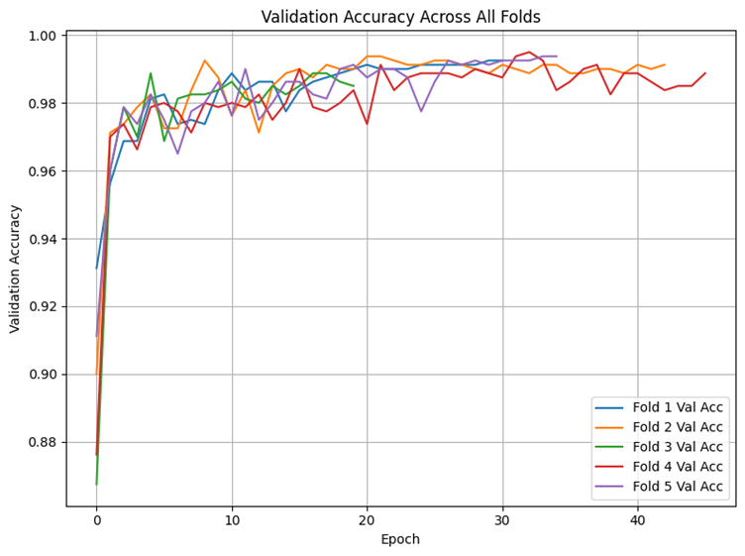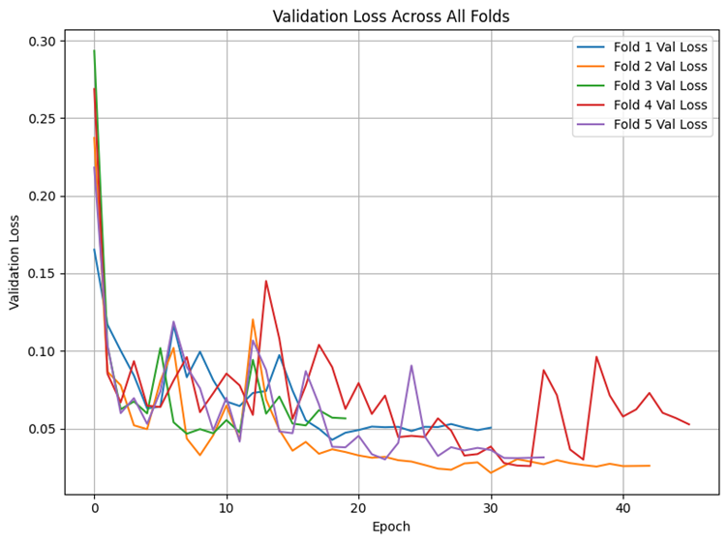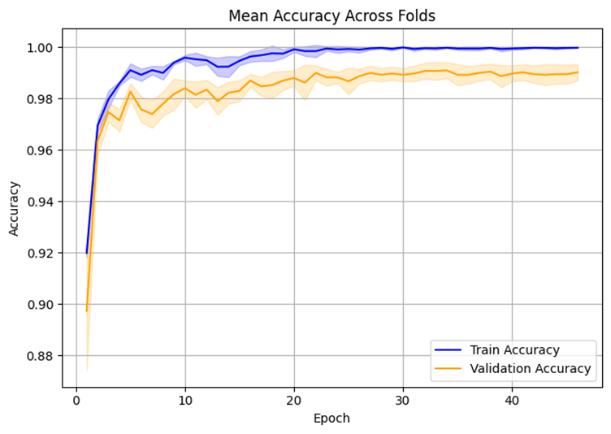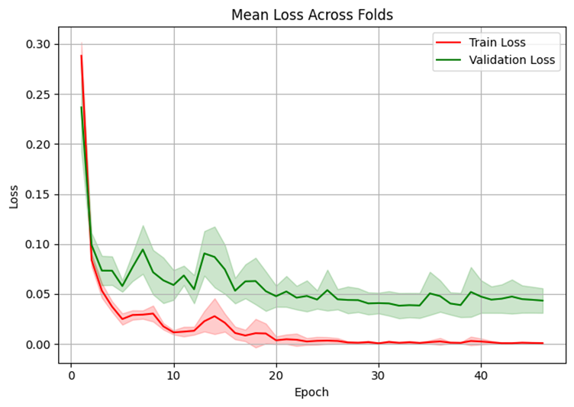

**Experiment 4: exp4_dropout_0.2_highLR_deepFT**

**Dropout Rate:** 0.2 | **Base LR:** 0.001 | **Fine-Tune LR:** 0.0001 | **Unfreeze Last N Layers:** 100 | **Batch Size:** 64 | **Epochs:** 1000 | **K-Folds:** 5 | **Input Size:** 299×299 | **Data Augmentation:** None

<https://colab.research.google.com/drive/188LW1hbkRjOPO6zy48m0Yhwa4eV8wycs?usp=sharing>

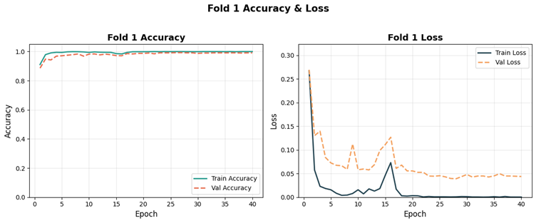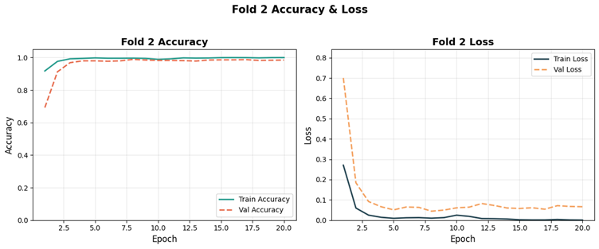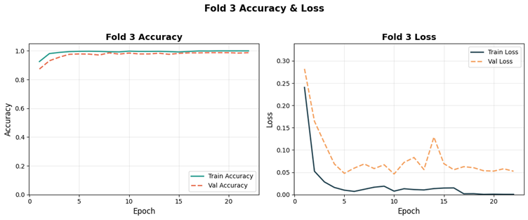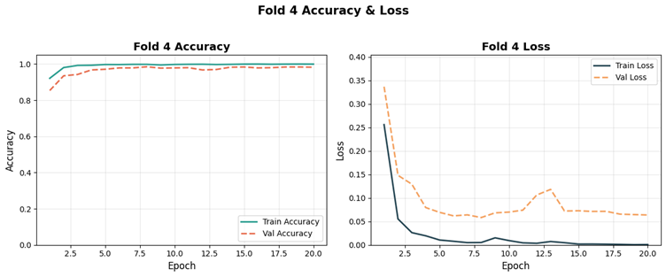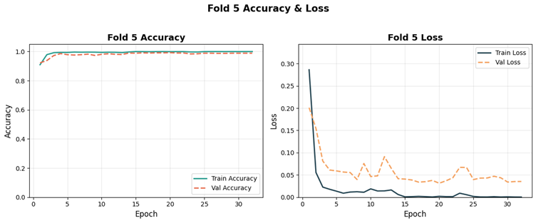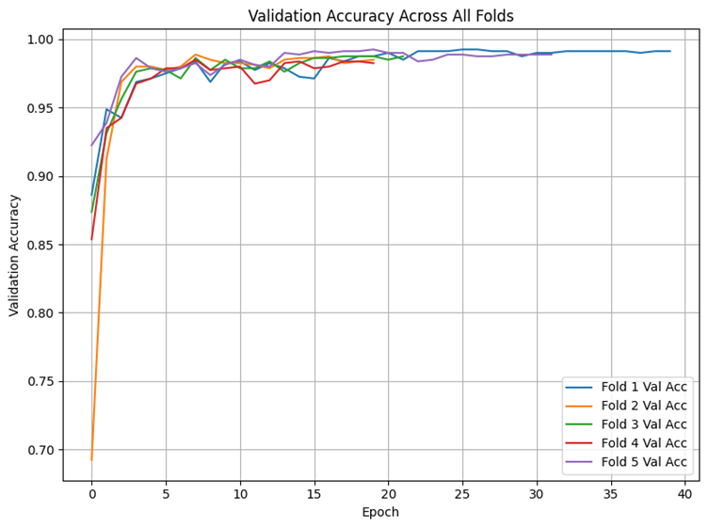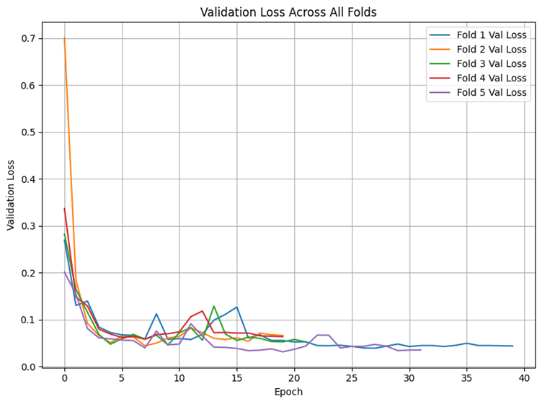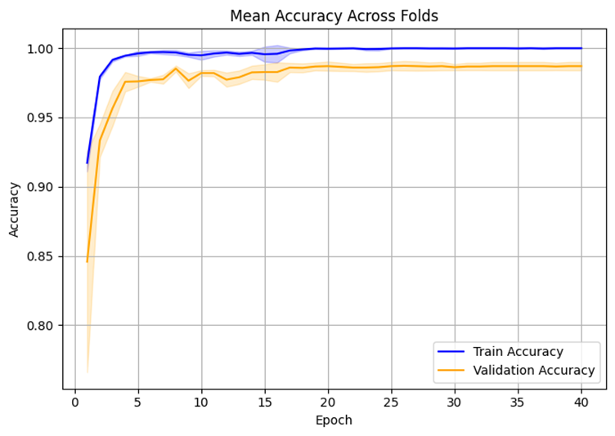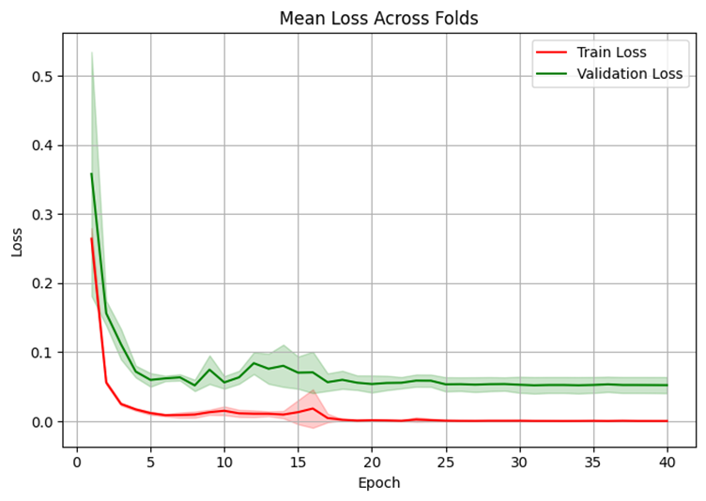

**Experiment 5: exp5_dropout_0.3**

**Dropout Rate:** 0.3 | **Base LR:** 0.0005 | **Fine-Tune LR:** 0.00005 | **Unfreeze Last N Layers:** 50 | **Batch Size:** 32 | **Epochs:** 1000 | **K-Folds:** 5 | **Input Size:** 299×299 | **Data Augmentation:** None

<https://colab.research.google.com/drive/1PH5Wb0tU8kW9xJbir22Kxal8f8adkpbt?usp=sharing>

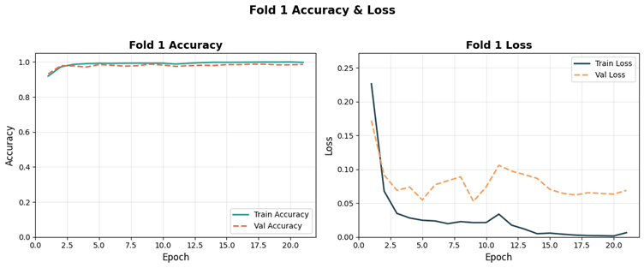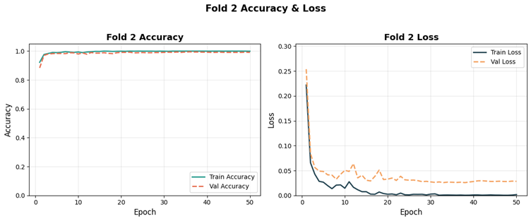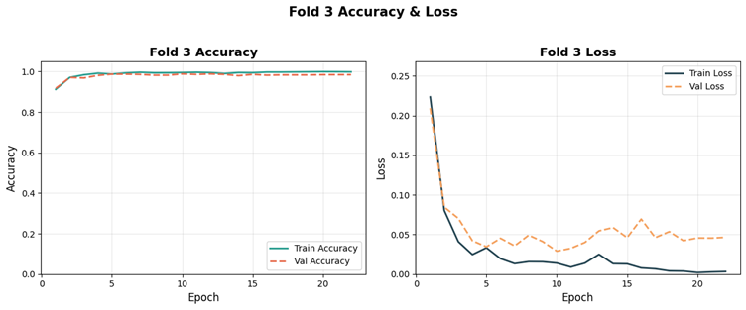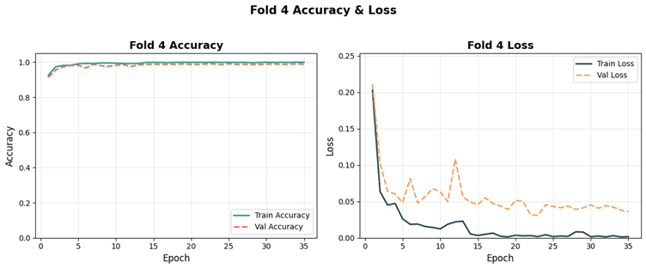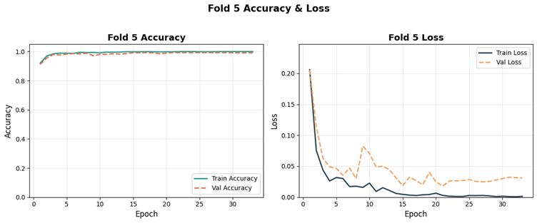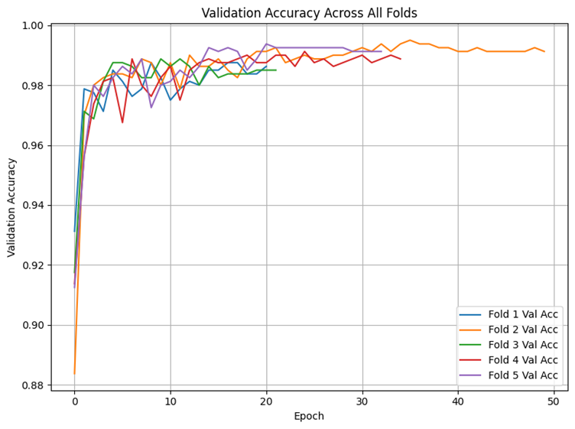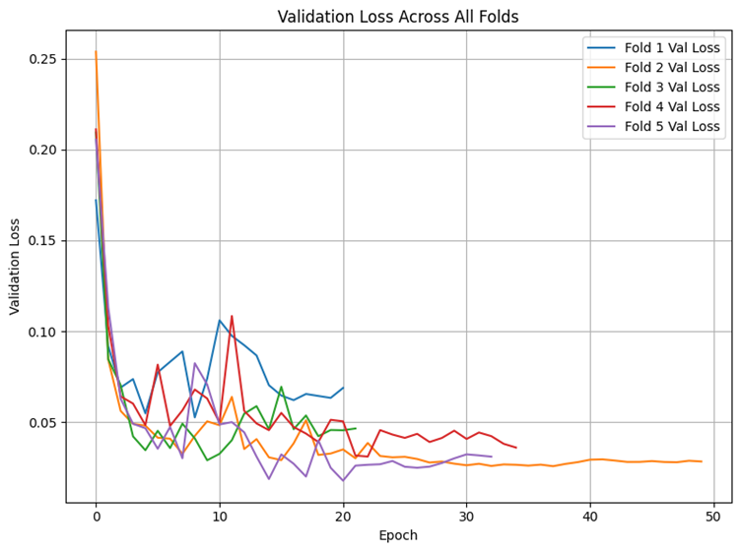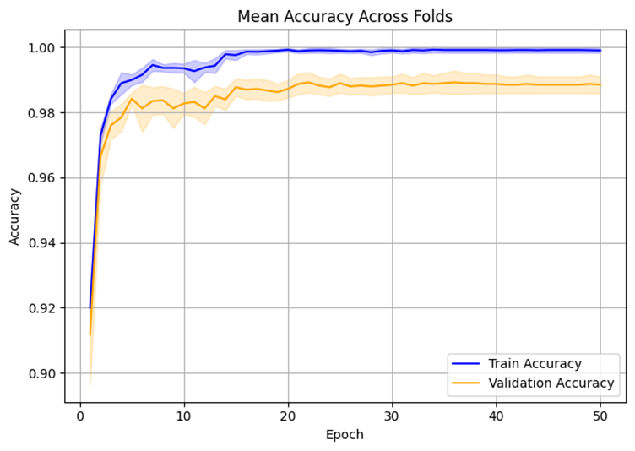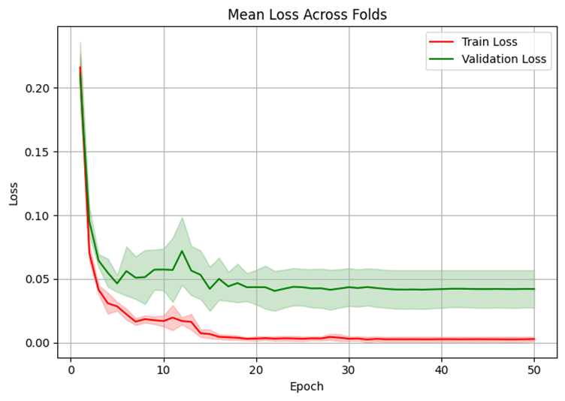

**Experiment 6: exp6_dropout_0.3_deepFT**

**Dropout Rate:** 0.3 | **Base LR:** 0.0005 | **Fine-Tune LR:** 0.00005 | **Unfreeze Last N Layers:** 100 | **Batch Size:** 32 | **Epochs:** 1000 | **K-Folds:** 5 | **Input Size:** 299×299 | **Data Augmentation:** None

<https://colab.research.google.com/drive/1FXz1C64KoA7A8i4aQAhcdcAHbB7krkTZ?usp=sharing>

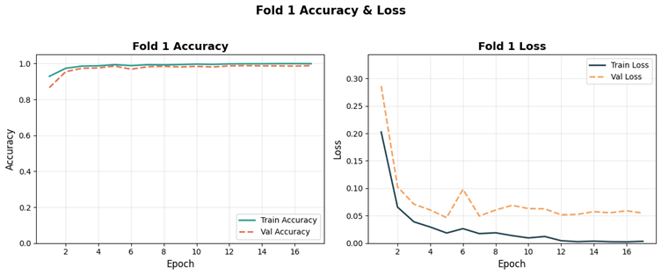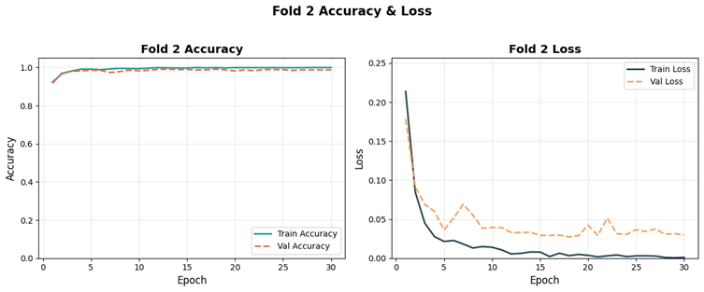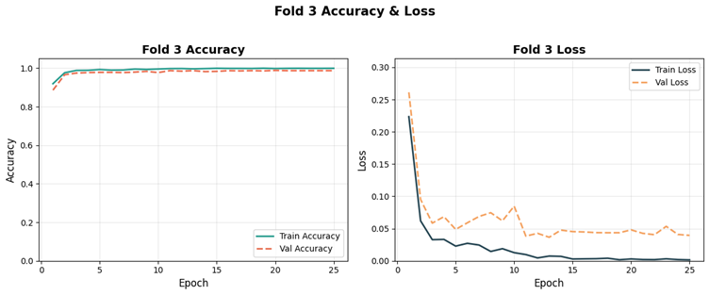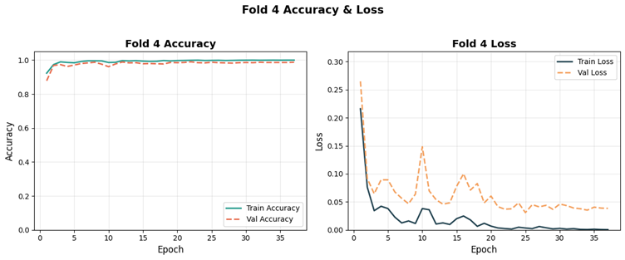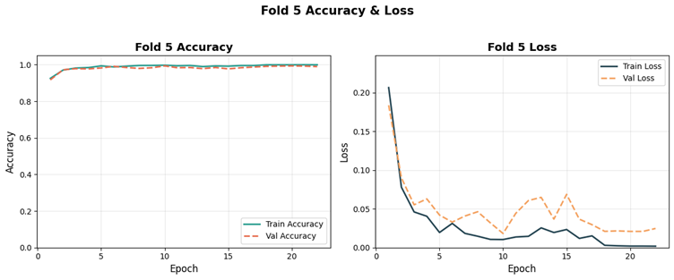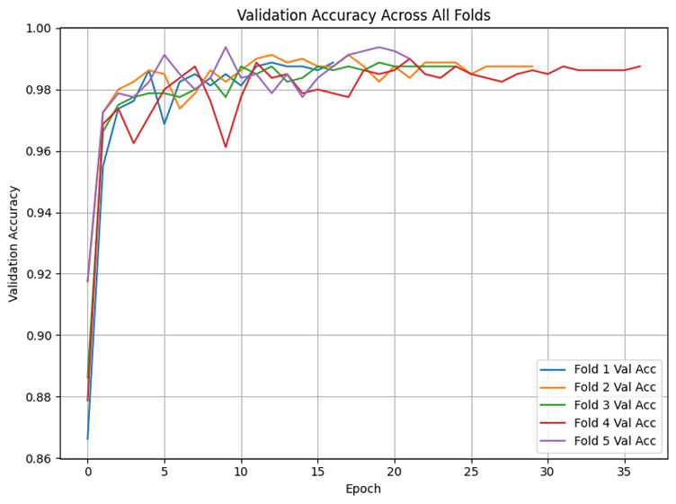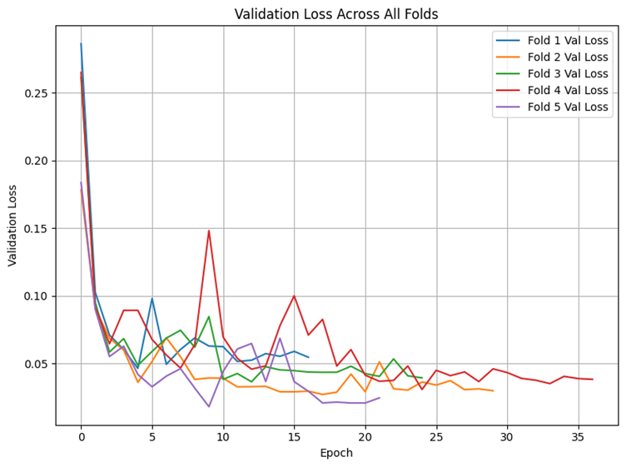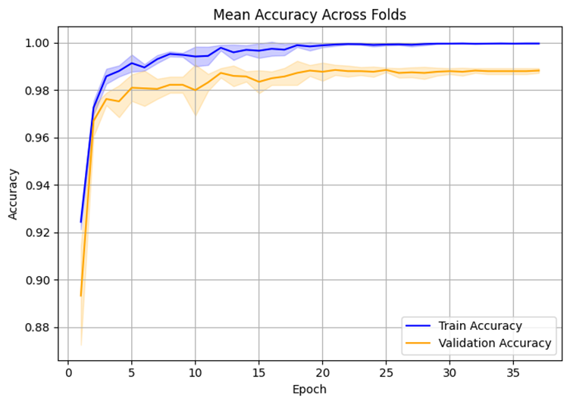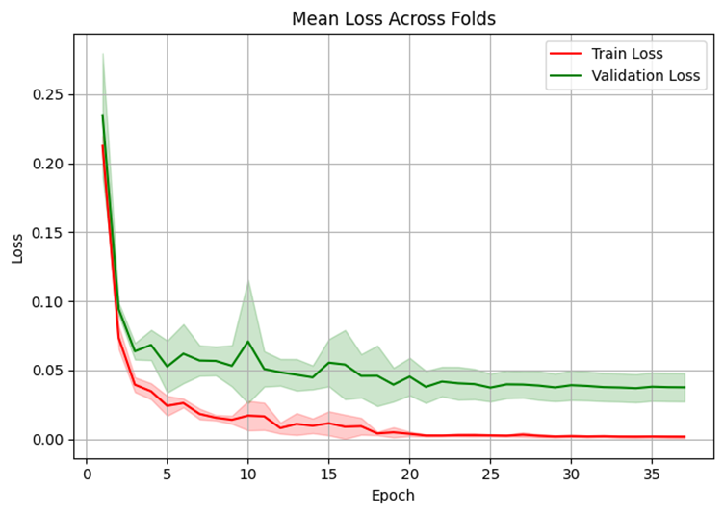

**Experiment 7: exp7_dropout_0.4_highLR**

**Dropout Rate:** 0.4 | **Base LR:** 0.001 | **Fine-Tune LR:** 0.0001 | **Unfreeze Last N Layers:** 50 | **Batch Size:** 32 | **Epochs:** 1000 | **K-Folds:** 5 | **Input Size:** 299×299 | **Data Augmentation:** None

<https://colab.research.google.com/drive/1bjCxmLkOVY9Ci_e2_pj-Jc2MwnjUkxME?usp=sharing>

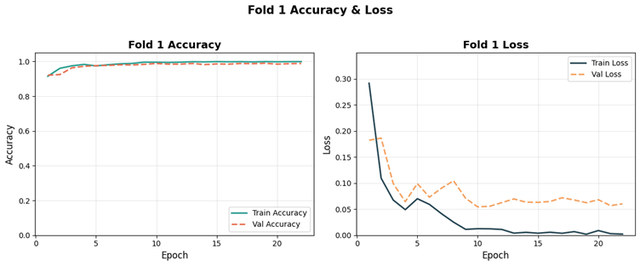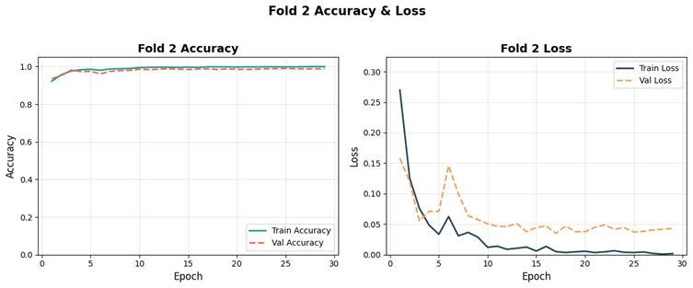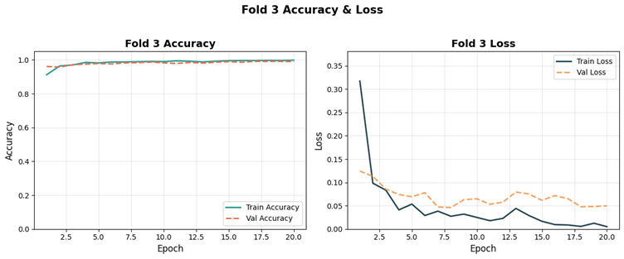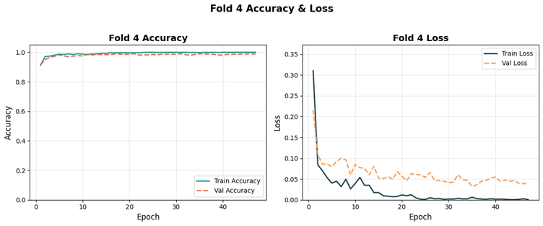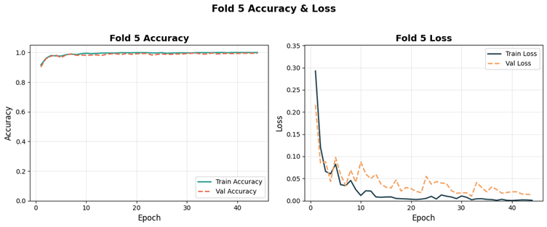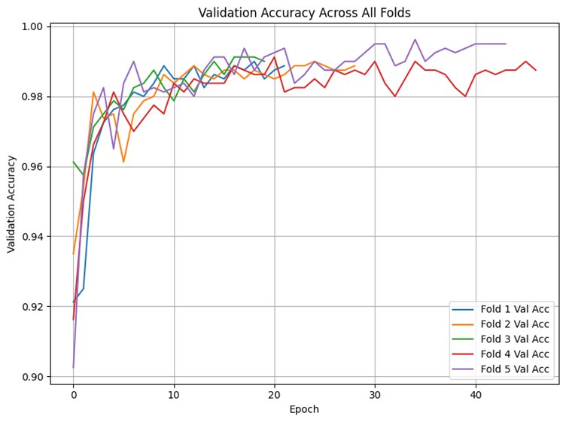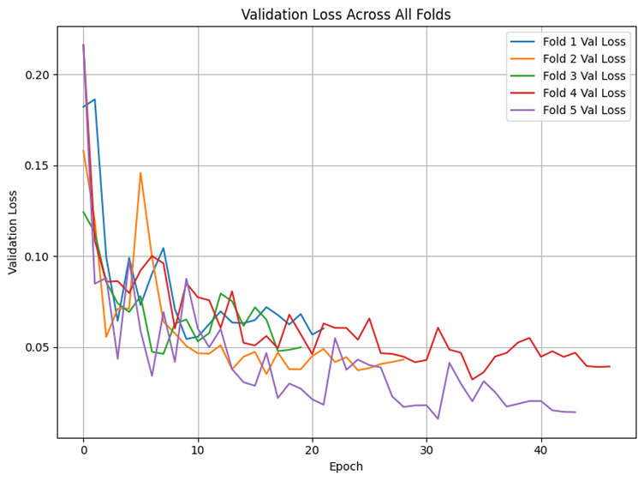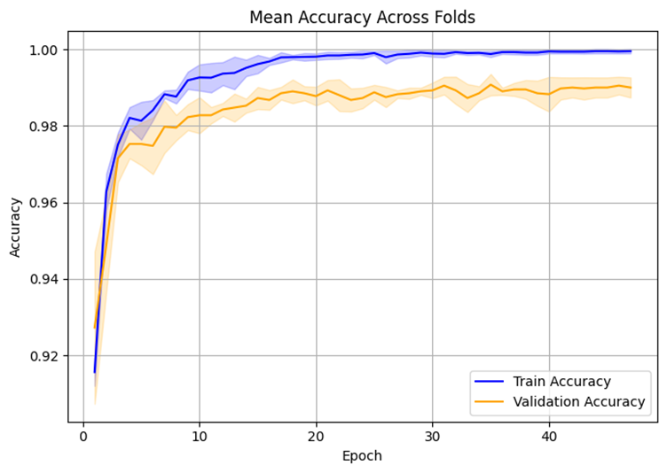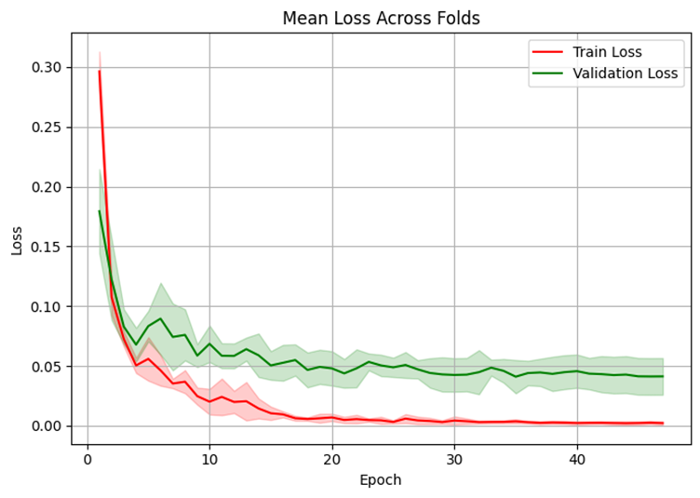

**Experiment 8: exp8_dropout_0.4_deepFT_smallBS**

**Dropout Rate:** 0.4 | **Base LR:** 0.0005 | **Fine-Tune LR:** 0.00005 | **Unfreeze Last N Layers:** 100 | **Batch Size:** 16 | **Epochs:** 1000 | **K-Folds:** 5 | **Input Size:** 299×299 | **Data Augmentation:** None

<https://colab.research.google.com/drive/1tEJO63oZdDgDHKa8pRfPRtHR2kKvn7g8?usp=sharing>

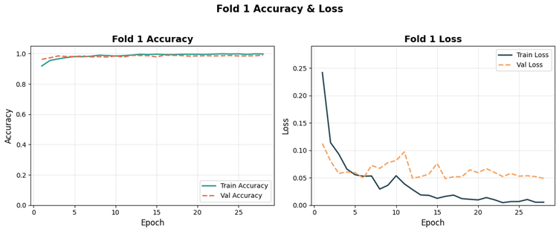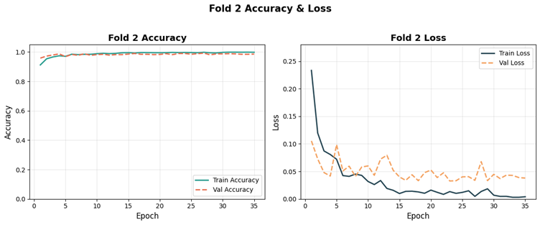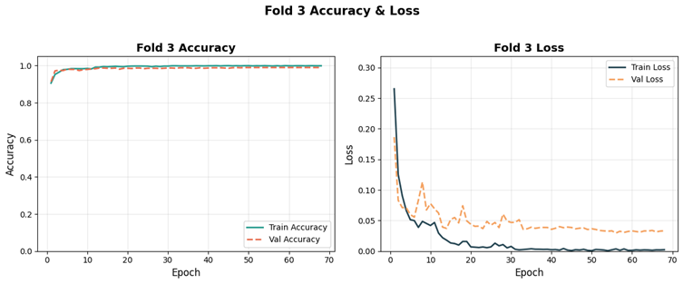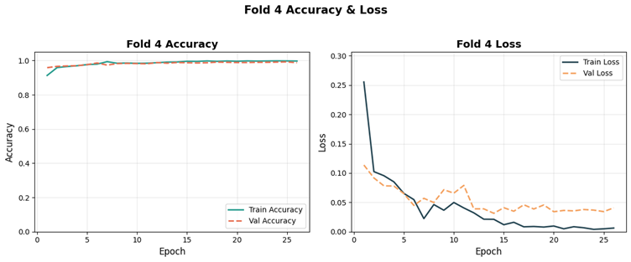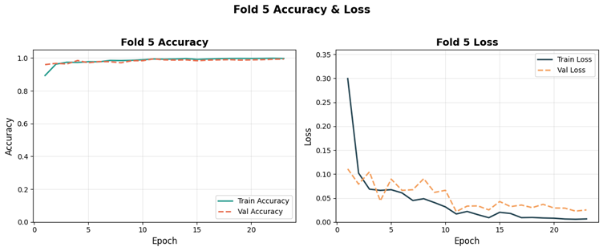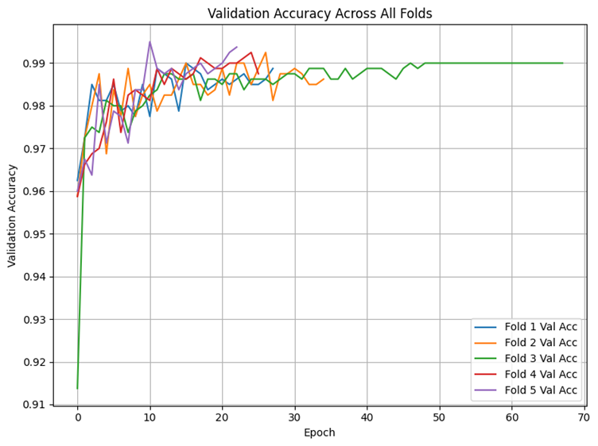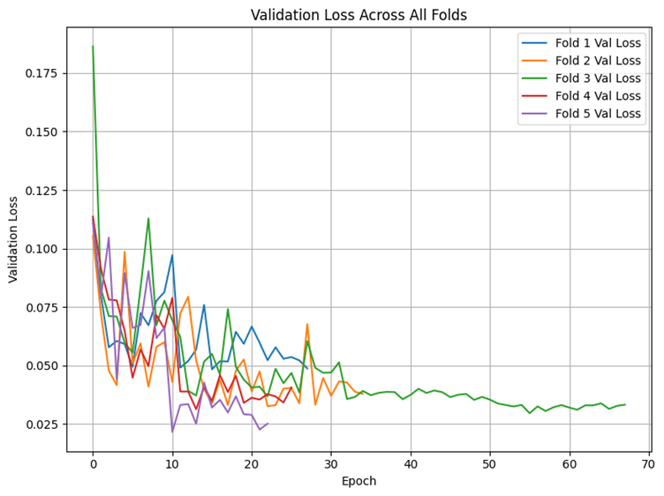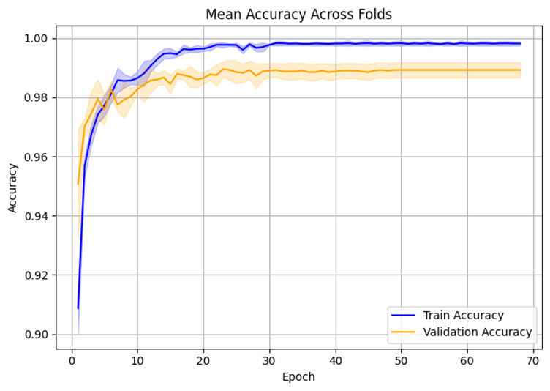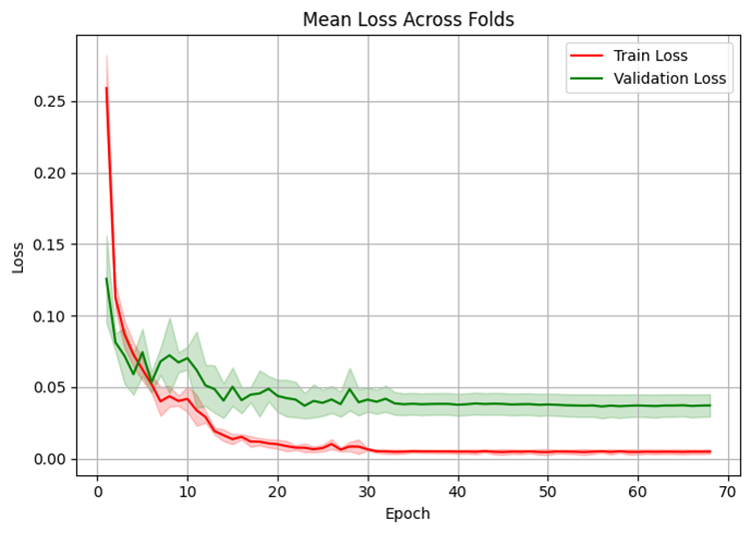

**Experiment 9: exp9_dropout0.3_baseLR**

**Dropout Rate:** 0.3 | **Base LR:** 0.0005 | **Fine-Tune LR:** 0.00005 | **Unfreeze Last N Layers:** 50 | **Batch Size:** 32 | **Epochs:** 1000 | **K-Folds:** 5 | **Input Size:** 299×299 | **Data Augmentation:** None

<https://colab.research.google.com/drive/1PH5Wb0tU8kW9xJbir22Kxal8f8adkpbt?usp=sharing>

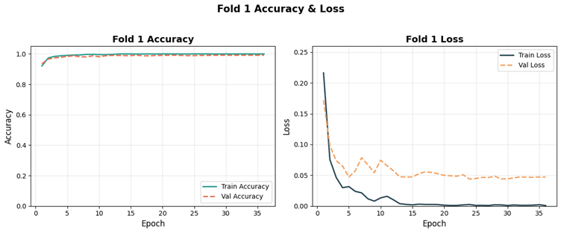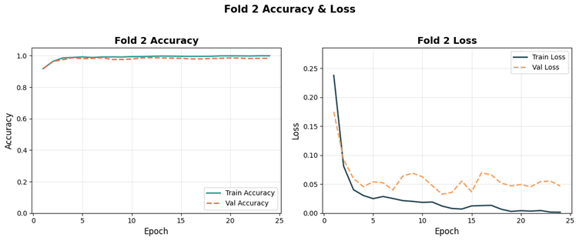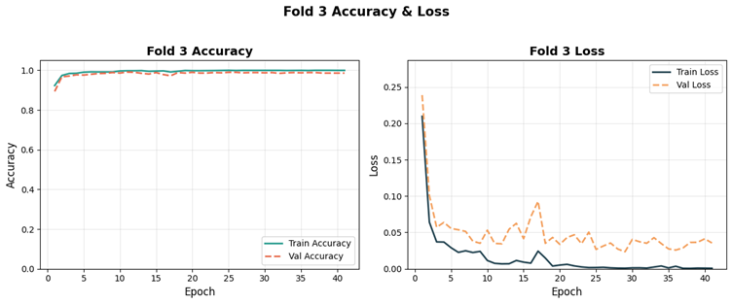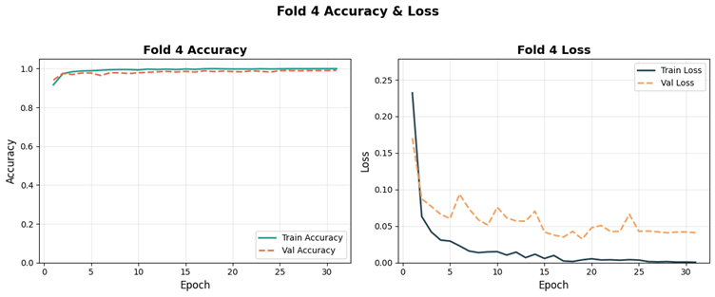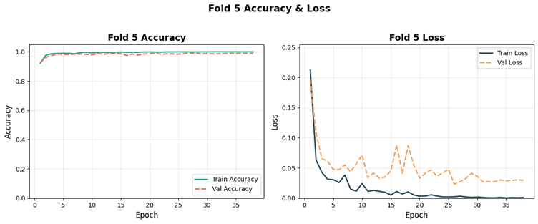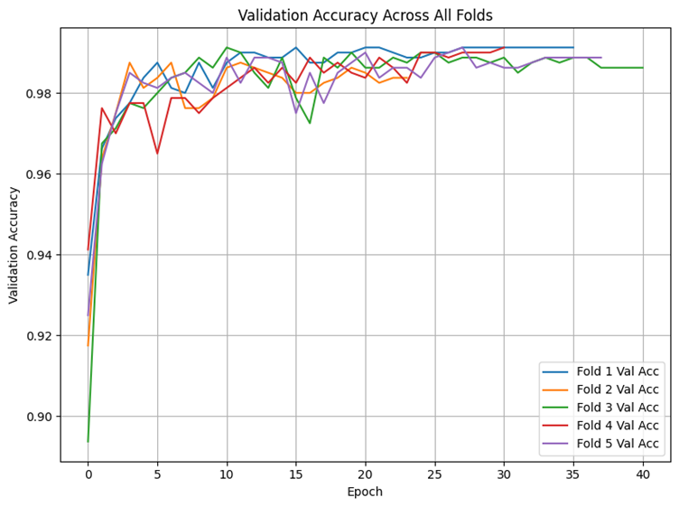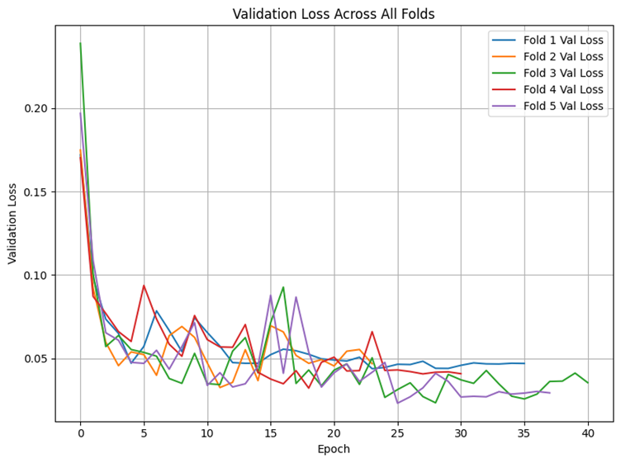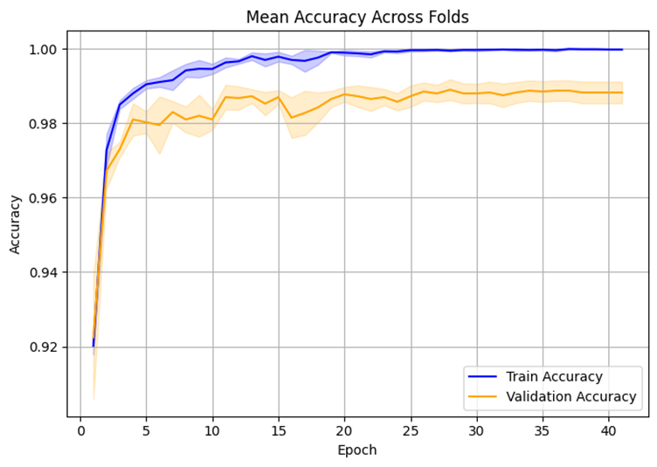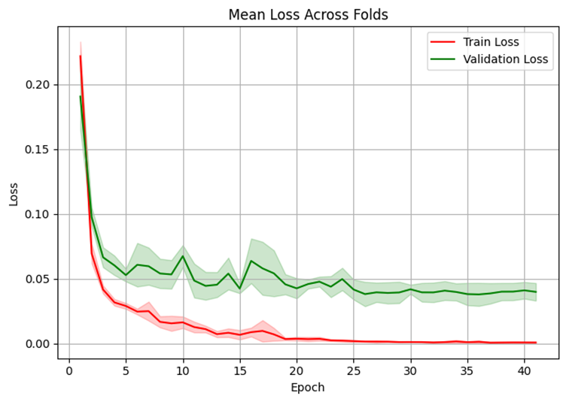

**Experiment 10: exp10_dropout0.4_smallBS**

**Dropout Rate:** 0.4 | **Base LR:** 0.0005 | **Fine-Tune LR:** 0.00005 | **Unfreeze Last N Layers:** 50 | **Batch Size:** 16 | **Epochs:** 1000 | **K-Folds:** 5 | **Input Size:** 299×299 | **Data Augmentation:** None

<https://colab.research.google.com/drive/1FXz1C64KoA7A8i4aQAhcdcAHbB7krkTZ?usp=sharing>

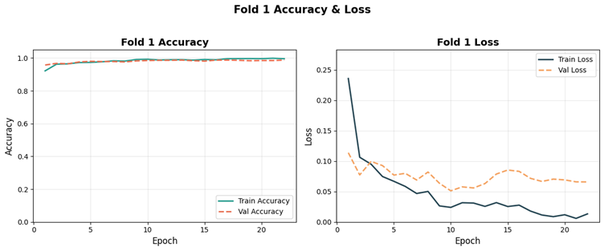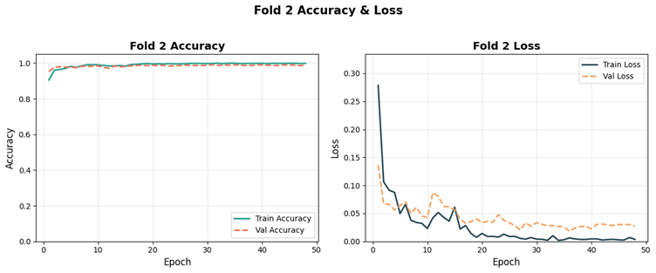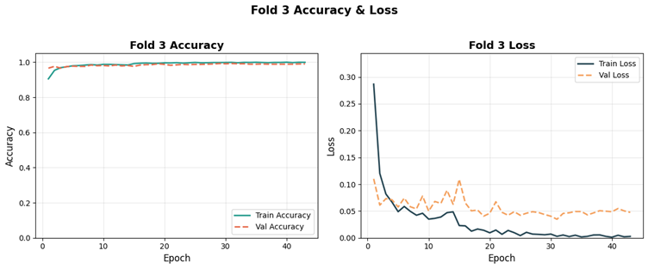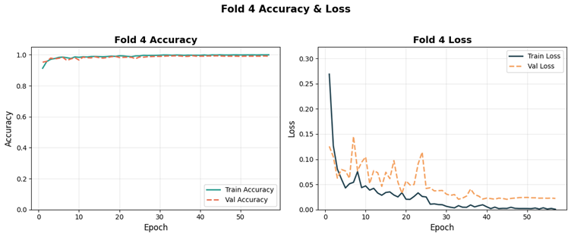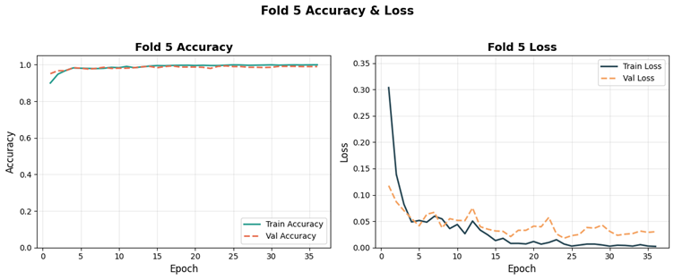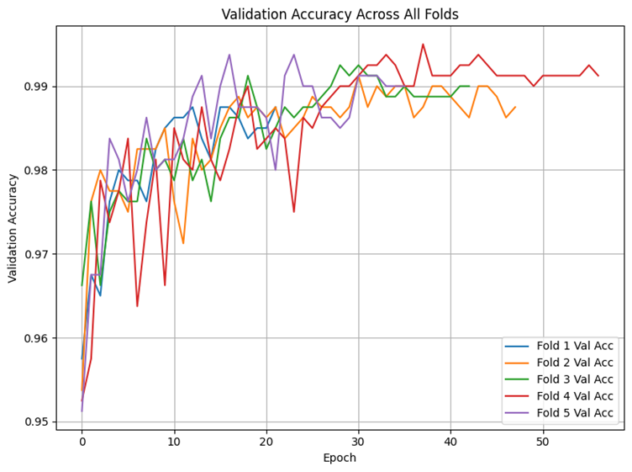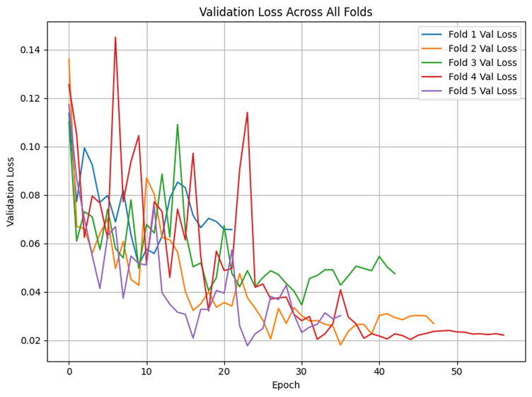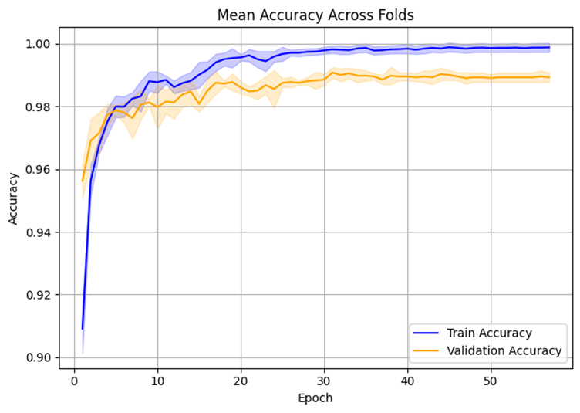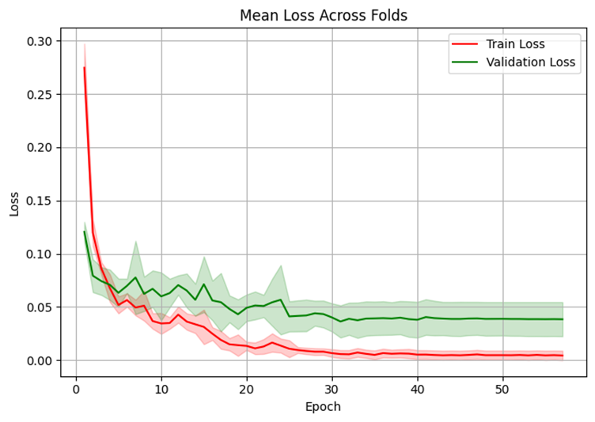

**Experiment 11: exp11_deepFT_lowLR**

**Dropout Rate:** 0.25 | **Base LR:** 0.0001 | **Fine-Tune LR:** 0.00001 | **Unfreeze Last N Layers:** 100 | **Batch Size:** 32 | **Epochs:** 1000 | **K-Folds:** 5 | **Input Size:** 299×299 | **Data Augmentation:** None

<https://colab.research.google.com/drive/1bjCxmLkOVY9Ci_e2_pj-Jc2MwnjUkxME?usp=sharing>

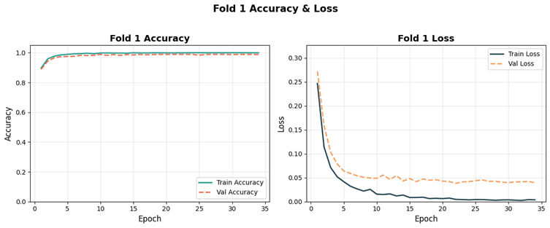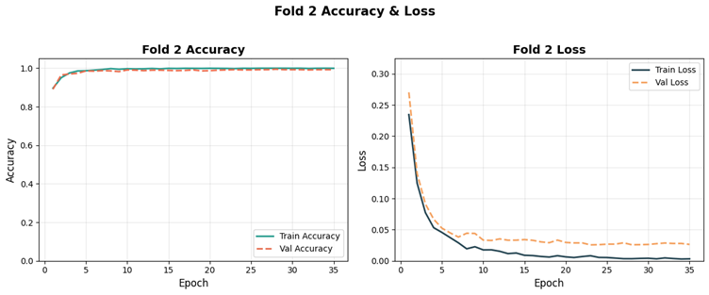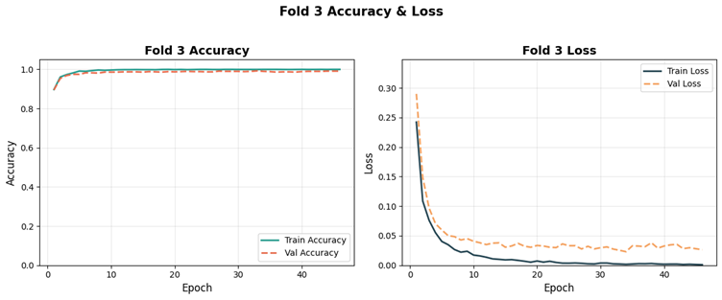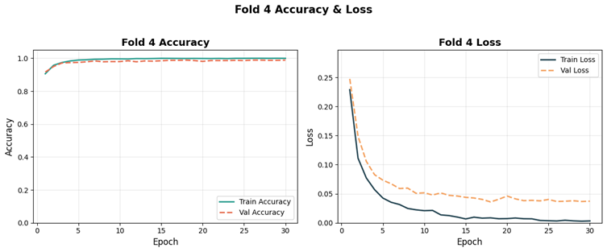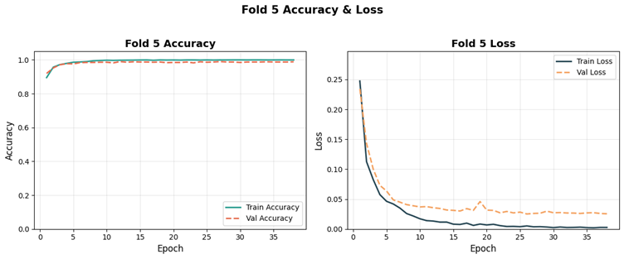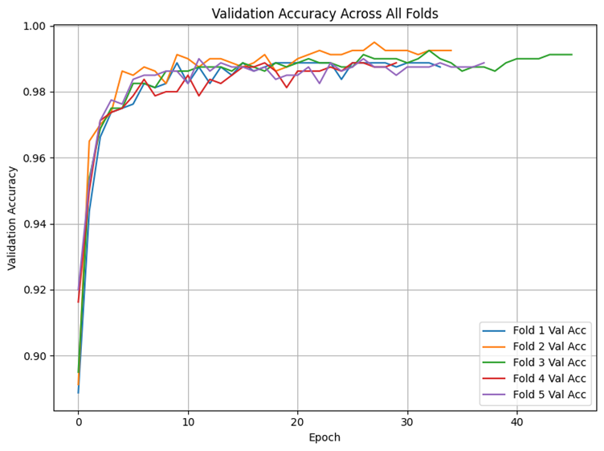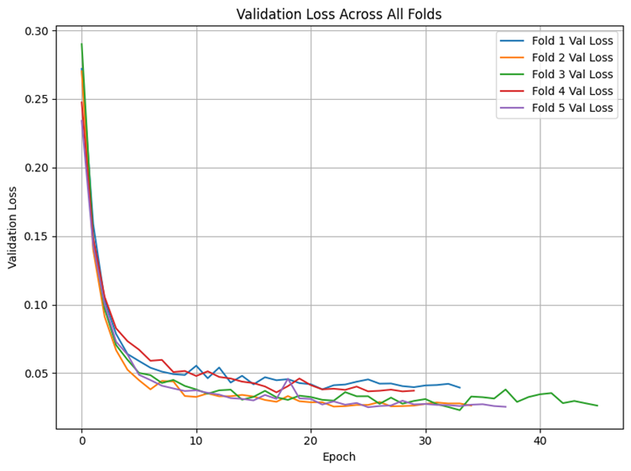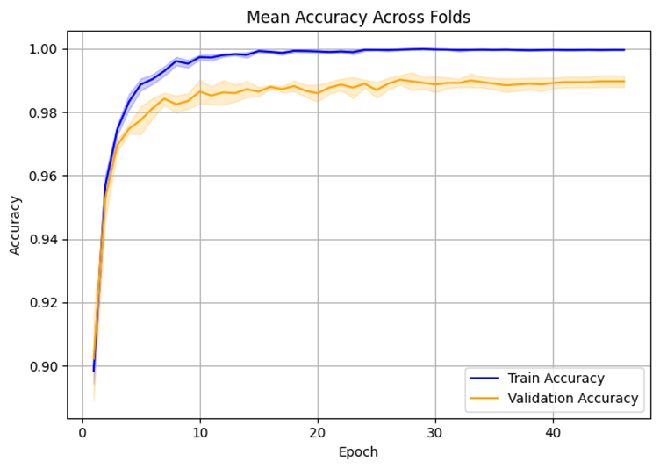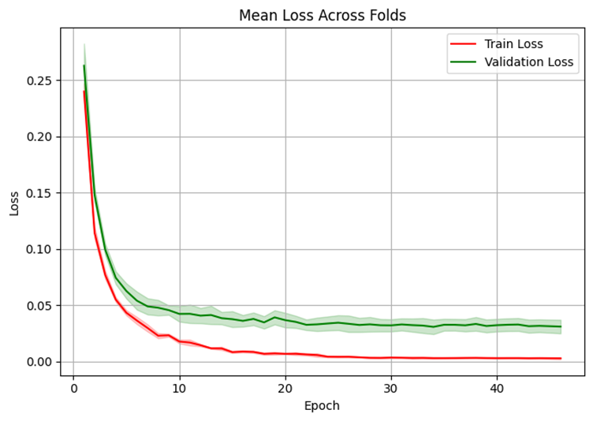

**Experiment 12: exp12_veryDeepFT_slowLR**

**Dropout Rate:** 0.1 | **Base LR:** 0.0001 | **Fine-Tune LR:** 0.000005 | **Unfreeze Last N Layers:** 150 | **Batch Size:** 32 | **Epochs:** 1000 | **K-Folds:** 5 | **Input Size:** 299×299 | **Data Augmentation:** None

<https://colab.research.google.com/drive/1tEJO63oZdDgDHKa8pRfPRtHR2kKvn7g8?usp=sharing>

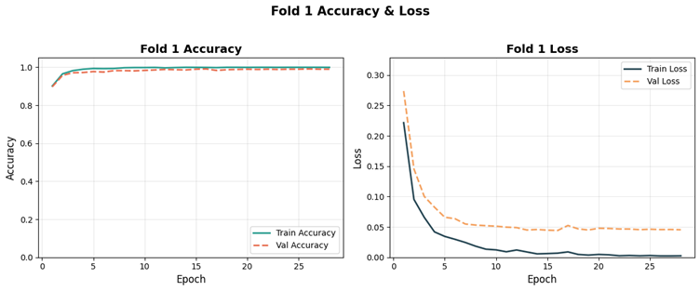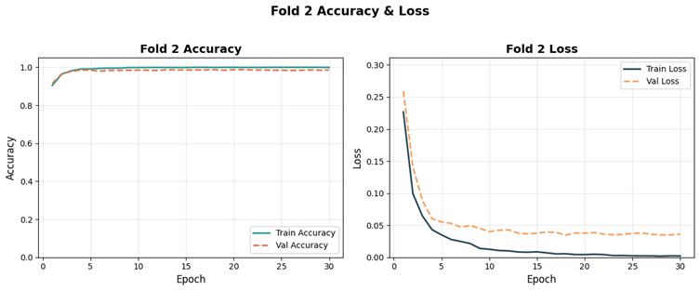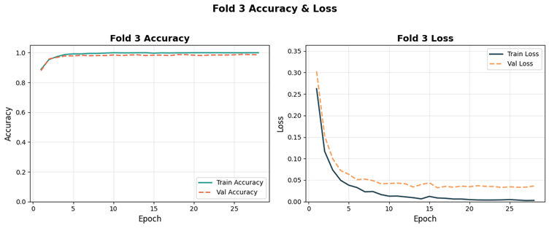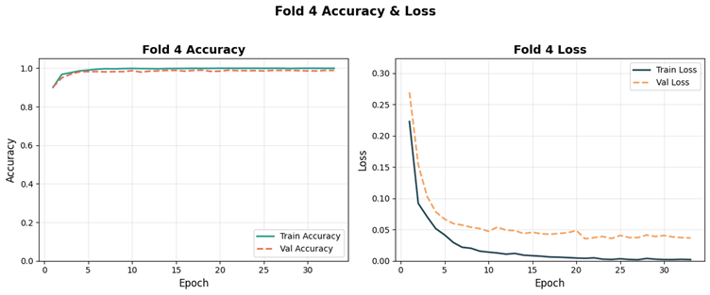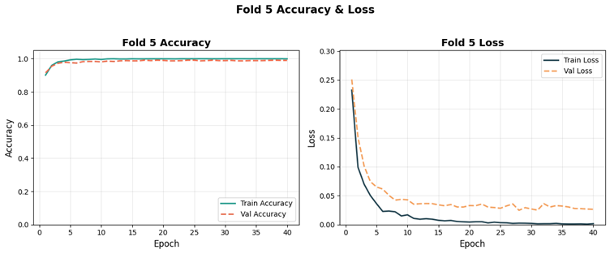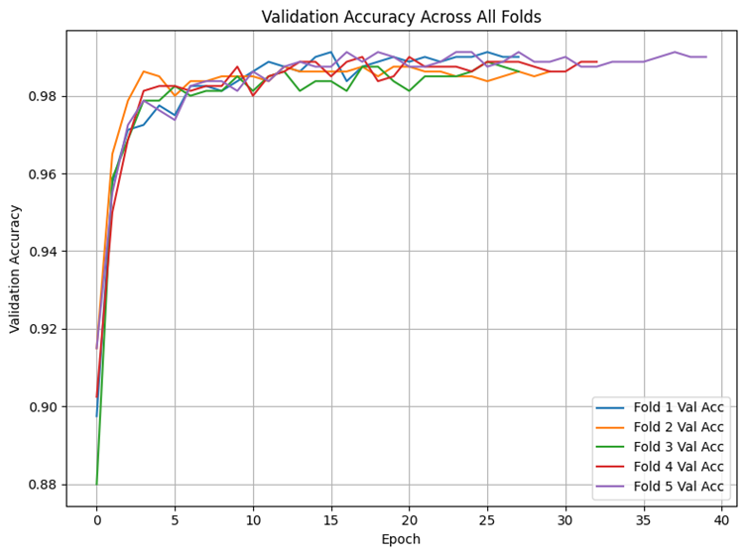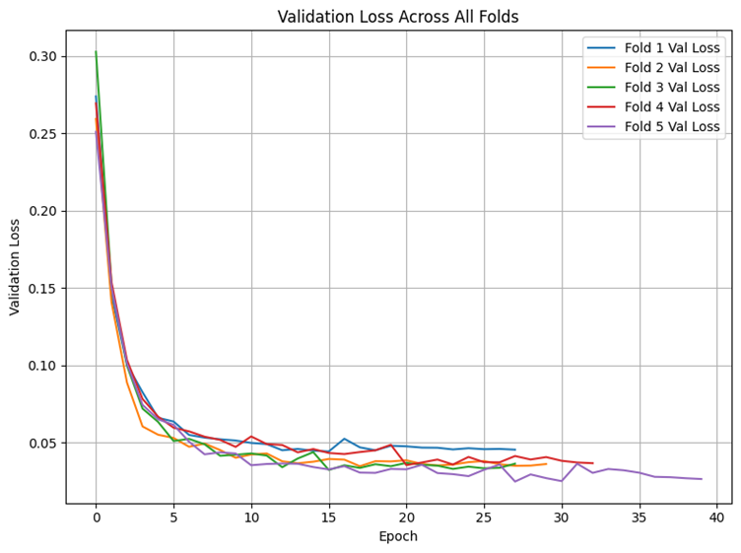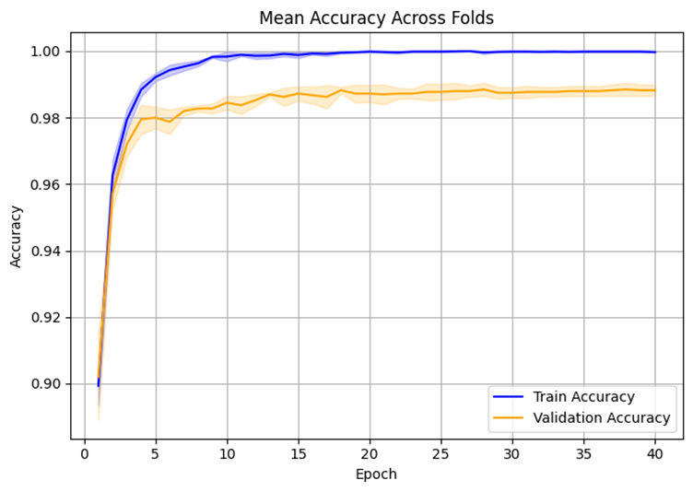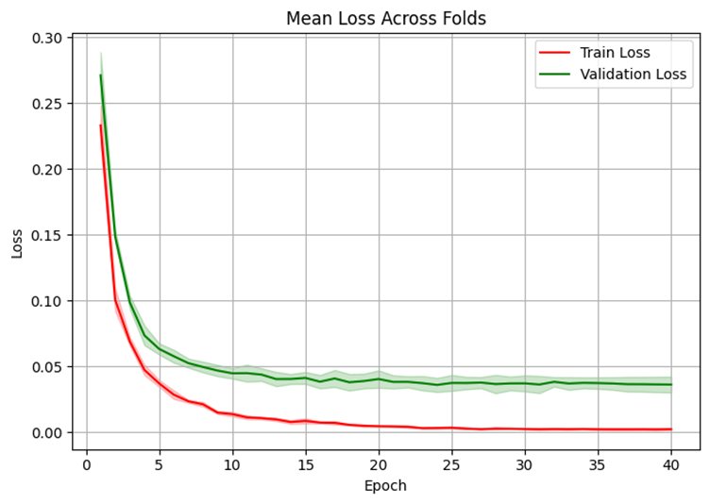

**7.5. Results of Multi-Class SCC Grading using EfficientNetB0 with Systematic Experimentation**

**7.5.1. Results - Experiment 1: Baseline Configuration**

**Experimental Setup**

|  |  |
| --- | --- |
| **Parameter** | **Value** |
| Configuration | Baseline |
| Dropout Rate | 0.35 |
| Regularization | L2 (2×10⁻⁴) |
| Learning Rate (Phase 1) | 7×10⁻⁵ |
| Learning Rate (Phase 2) | 2×10⁻⁶ |
| Total Epochs | ~60 |
| Hardware | NVIDIA A100 80GB |

**Training Performance**

**Loss and Accuracy Curves**

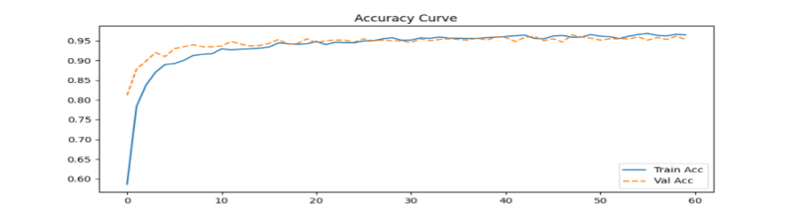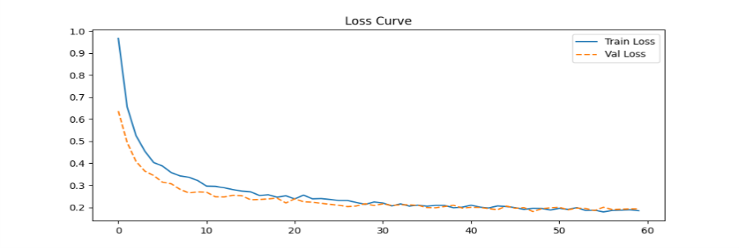                         **Fig 7.10.**Acc Loss curve of Efficientnetb0 exp1

The loss curve demonstrates excellent convergence characteristics with training loss decreasing from 0.97 to approximately 0.19 over 60 epochs. Validation loss follows closely, starting at 0.65 and stabilizing around 0.19-0.20. The curves remain tightly aligned throughout training, with validation loss consistently tracking or slightly below training loss, indicating effective regularization through the combination of L2 penalty (2×10⁻⁴) and moderate dropout (0.35).

The accuracy curve reveals rapid initial learning, with training accuracy rising from 58% to 90% within the first 10 epochs during Phase 1. Validation accuracy demonstrates strong early performance, reaching 81% after epoch 1 and climbing to 89% by epoch 3. During fine-tuning (epochs 11-60), both metrics improve steadily, reaching approximately 95.5% training and 95.6% validation accuracy by the final epoch. The near-perfect overlap of curves confirms robust generalization without overfitting.

**Classification Results**

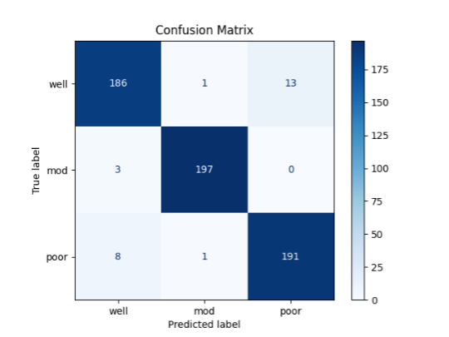

**Fig 7.11.**Confusion Matrix of Efficientnetb0 exp1

**Performance Metrics**

|  |  |
| --- | --- |
| **Metric** | **Value** |
| Final Training Accuracy | ~95.5% |
| Final Validation Accuracy | ~95.6% |
| Final Training Loss | ~0.19 |
| Final Validation Loss | ~0.20 |
| Overall Validation Accuracy | 96.5% (579/600) |

**Per-Class Performance**

|  |  |  |  |  |
| --- | --- | --- | --- | --- |
| **Class** | **Correct** | **Total** | **Recall** | **Misclassified As** |
| Well-differentiated | 186 | 200 | 93.0% | Mod: 1, Poor: 13 |
| Moderately-differentiated | 197 | 200 | 98.5% | Well: 3, Poor: 0 |
| Poorly-differentiated | 191 | 200 | 95.5% | Well: 8, Mod: 1 |

**Key Findings**

The baseline configuration achieved strong validation accuracy of 96.5% (579/600 correct classifications), establishing an effective benchmark for subsequent experiments. The balanced dropout (0.35) and L2 regularization (2×10⁻⁴) combination successfully prevented overfitting while maintaining high discriminative performance across all three SCC grades.

Per-class analysis reveals "moderately-differentiated" achieved the highest recall (98.5%), with only 3 misclassifications as "well" and zero confusion with "poor." The "poorly-differentiated" class showed 95.5% recall with minimal confusion (8 to "well", 1 to "mod"). The "well-differentiated" class exhibited the lowest recall (93.0%), with most errors (13 cases) misclassified as "poorly-differentiated," suggesting biological heterogeneity in this category.

A key observation is the asymmetric confusion pattern: "well" samples are frequently misclassified as "poor" (13 cases), while "poor" samples show moderate confusion with "well" (8 cases), but "mod" demonstrates clear separation from "poor" (zero misclassifications in either direction). This indicates the model learned robust decision boundaries between moderately and poorly differentiated grades.

The excellent alignment of training and validation metrics (95.5% vs 95.6% accuracy, 0.19 vs 0.20 loss) throughout the entire training process demonstrates that the baseline regularization strategy effectively balances model capacity with generalization, making this configuration suitable for reliable SCC grading in clinical applications.

**Grad-CAM Visualizations**

Below are the Grad-CAM visualizations showing the model's attention regions for each of the three SCC differentiation grades. The heatmaps highlight which regions of the histopathological images were most influential in the classification decisions, providing interpretability and clinical validation of the automated grading system.

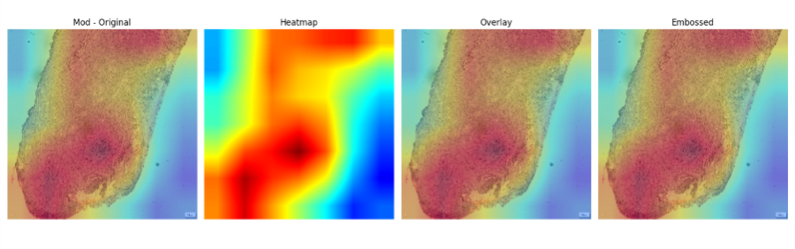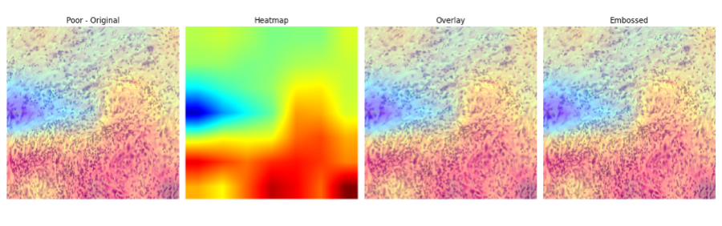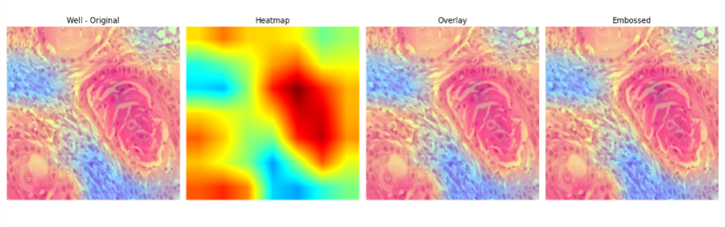**Fig 7.12.**Gradcam Visualization of Efficientnetb0 exp1

**7.5.2. Results - Experiment 2: No Regularization Configuration**

**Experimental Setup**

|  |  |
| --- | --- |
| **Parameter** | **Value** |
| Configuration | No Regularization (Control) |
| Dropout Rate | 0.0 |
| Regularization | None |
| Learning Rate (Phase 1) | 7×10⁻⁵ |
| Learning Rate (Phase 2) | 2×10⁻⁶ |
| Total Epochs | ~80 |
| Hardware | NVIDIA A100 80GB |

**Training Performance**

**Loss and Accuracy Curves**

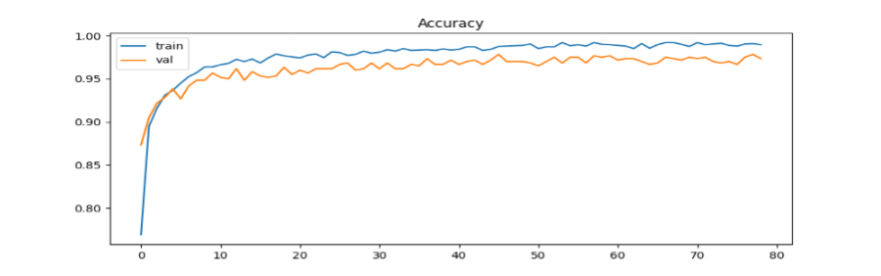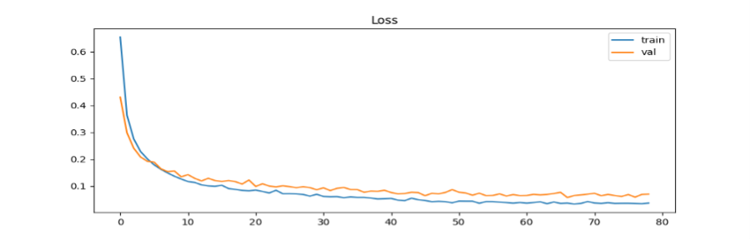                                                **Fig 7.13.**Acc Loss curve of Efficientnetb0 exp2

The loss curve reveals rapid initial convergence with training loss dropping sharply from 0.65 to approximately 0.10 within the first 10 epochs. However, a notable divergence emerges between training and validation loss curves after epoch 20. Training loss continues to decrease steadily, reaching approximately 0.05 by epoch 80, while validation loss plateaus around 0.07-0.08, indicating early signs of overfitting due to the absence of regularization mechanisms.

The accuracy curve demonstrates aggressive learning in the initial phase, with training accuracy climbing from 77% to 95% within the first 10 epochs. Validation accuracy follows closely, reaching 93% early in training. Beyond epoch 15, training accuracy continues improving toward 99%, while validation accuracy stabilizes around 97%, creating a widening gap. This divergence pattern is characteristic of overfitting, as the model memorizes training data without regularization constraints.

**Classification Results**

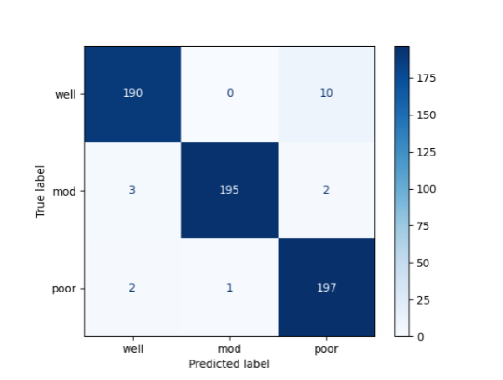

**Fig 7.14.**Confusion Matrix of Efficientnetb0 exp2

**Performance Metrics**

|  |  |
| --- | --- |
| **Metric** | **Value** |
| Final Training Accuracy | ~99.0% |
| Final Validation Accuracy | ~97.0% |
| Final Training Loss | ~0.05 |
| Final Validation Loss | ~0.07 |
| Overall Validation Accuracy | 97.0% (582/600) |

**Per-Class Performance**

|  |  |  |  |  |
| --- | --- | --- | --- | --- |
| **Class** | **Correct** | **Total** | **Recall** | **Misclassified As** |
| Well-differentiated | 190 | 200 | 95.0% | Mod: 0, Poor: 10 |
| Moderately-differentiated | 195 | 200 | 97.5% | Well: 3, Poor: 2 |
| Poorly-differentiated | 197 | 200 | 98.5% | Well: 2, Mod: 1 |

**Key Findings**

Experiment 2 achieved the highest validation accuracy (97.0%) among early experiments, with overall correct classification of 582 out of 600 validation samples. The removal of dropout and regularization allowed the model to learn more complex decision boundaries, resulting in improved per-class recall rates: 95.0% for well-differentiated, 97.5% for moderately-differentiated, and 98.5% for poorly-differentiated grades.

However, the widening gap between training (~99%) and validation (~97%) accuracy, along with the divergence in loss curves, indicates overfitting tendencies. The model achieved near-perfect performance on training data while validation performance plateaued earlier. Despite this, the 97% validation accuracy demonstrates that the EfficientNetB0 architecture with sufficient capacity can achieve strong generalization even without explicit regularization, likely due to implicit regularization from data augmentation and the pretrained backbone.

The confusion matrix shows improved performance on the "well-differentiated" class (95.0% recall vs. 91.5% in Exp 1), with all misclassifications directed toward "poorly-differentiated" rather than "moderately-differentiated." The "poorly-differentiated" class achieved the highest recall (98.5%), suggesting clearer morphological boundaries. This experiment establishes that while regularization mechanisms help prevent overfitting, the model's inherent capacity and transfer learning enable strong baseline performance even in their absence.

**Grad-CAM Visualizations**

Below are the Grad-CAM visualizations showing the model's attention regions for each of the three SCC differentiation grades in the absence of regularization. The heatmaps demonstrate how the unconstrained model focuses on histopathological features for classification decisions.

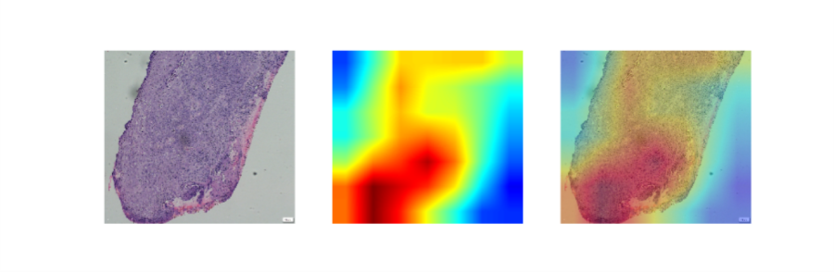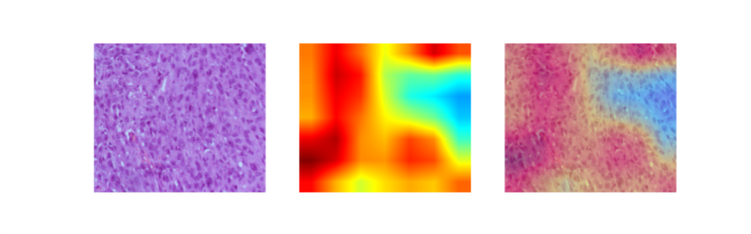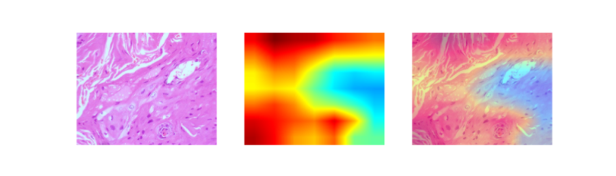**Fig 7.15.**Gradcam Visualization of Efficientnetb0 exp2

**7.5.3. Results - Experiment 3: High Dropout Configuration**

**Experimental Setup**

|  |  |
| --- | --- |
| **Parameter** | **Value** |
| Configuration | High Dropout with L2 |
| Dropout Rate | 0.50 |
| Regularization | L2 (2×10⁻⁴) |
| Learning Rate (Phase 1) | 7×10⁻⁵ |
| Learning Rate (Phase 2) | 2×10⁻⁶ |
| Total Epochs | ~100 |
| Hardware | NVIDIA A100 80GB |

**Training Performance**

**Loss and Accuracy Curves**

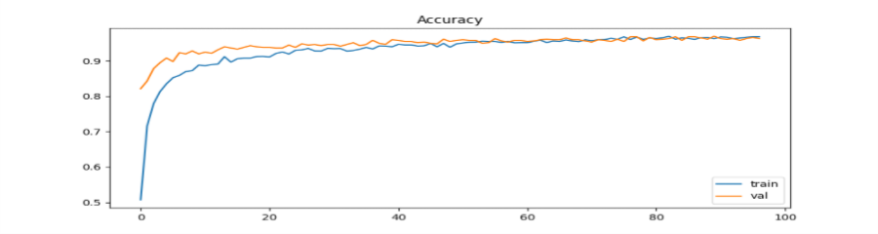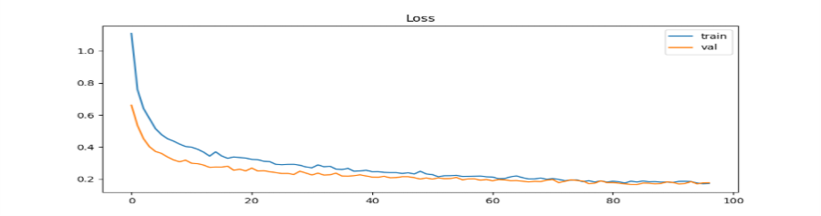**Fig 7.16.**Acc Loss curve of Efficientnetb0 exp3

The loss curve demonstrates smooth convergence with strong regularization effects. Training loss decreases from 1.10 to approximately 0.18 over 100 epochs, following a gradual descent pattern. Validation loss exhibits parallel behavior, starting at 0.65 and stabilizing around 0.18-0.19. The curves remain tightly coupled throughout training, with validation loss occasionally dipping below training loss, indicating that the aggressive dropout (0.50) combined with L2 regularization effectively prevents overfitting.

The accuracy curve shows steady but slower initial learning compared to lower dropout configurations. Training accuracy rises from 50% to 88% in the first 10 epochs, then continues improving gradually to reach approximately 95% by epoch 100. Validation accuracy demonstrates remarkable stability, starting at 82% and climbing consistently to plateau around 95-96%. The near-perfect overlap of training and validation curves throughout the entire training process confirms excellent generalization with minimal overfitting risk.

**Classification Results**

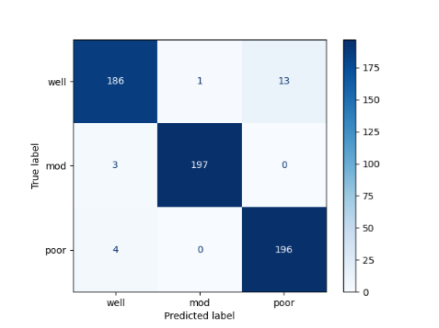

**Fig 7.17.**Confusion Matrix of Efficientnetb0 exp3

### **Performance Metrics**

|  |  |
| --- | --- |
| **Metric** | **Value** |
| Final Training Accuracy | ~95.5% |
| Final Validation Accuracy | ~95.8% |
| Final Training Loss | ~0.18 |
| Final Validation Loss | ~0.18 |
| Overall Validation Accuracy | 96.5% (579/600) |

### **Per-Class Performance**

|  |  |  |  |  |
| --- | --- | --- | --- | --- |
| **Class** | **Correct** | **Total** | **Recall** | **Misclassified As** |
| Well-differentiated | 186 | 200 | 93.0% | Mod: 1, Poor: 13 |
| Moderately-differentiated | 197 | 200 | 98.5% | Well: 3, Poor: 0 |
| Poorly-differentiated | 196 | 200 | 98.0% | Well: 4, Mod: 0 |

### **Key Findings**

Experiment 3 achieved exceptional validation accuracy of 96.5% (579/600 correct classifications) with remarkably balanced generalization. The high dropout rate (0.50) combined with L2 regularization created strong regularization pressure, resulting in virtually identical training and validation performance (95.5% vs 95.8%), demonstrating superior generalization compared to previous experiments.

The per-class performance reveals interesting patterns: "moderately-differentiated" achieved the highest recall (98.5%), with zero misclassifications as "poorly-differentiated." Similarly, "poorly-differentiated" achieved 98.0% recall with no confusion with the "mod" class. The "well-differentiated" class shows 93.0% recall, slightly improved from Exp 1 (91.5%) but with persistent confusion toward "poorly-differentiated" (13 cases), suggesting inherent biological overlap between these categories.

A notable finding is the elimination of confusion between "mod" and "poor" classes in both directions, indicating that high dropout forces the model to learn more robust, generalizable features that clearly distinguish these categories. The extended training duration (~100 epochs vs. 42 in Exp 1) compensates for the slower learning imposed by aggressive dropout, ultimately achieving comparable or superior performance with enhanced stability.

The loss curves' perfect alignment and the validation accuracy matching or exceeding training accuracy demonstrate that high dropout (0.50) successfully prevents overfitting while maintaining discriminative power, making this configuration highly suitable for deployment scenarios requiring robust generalization.

## **Grad-CAM Visualizations**

Below are the Grad-CAM visualizations showing the model's attention regions for each of the three SCC differentiation grades under high dropout regularization. The heatmaps reveal how aggressive regularization influences feature focus and decision-making patterns across the histopathological images.

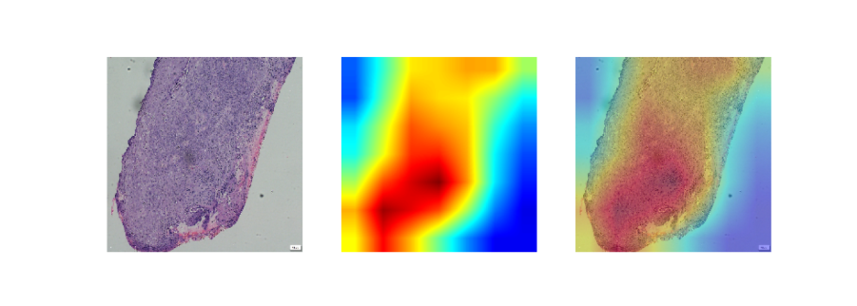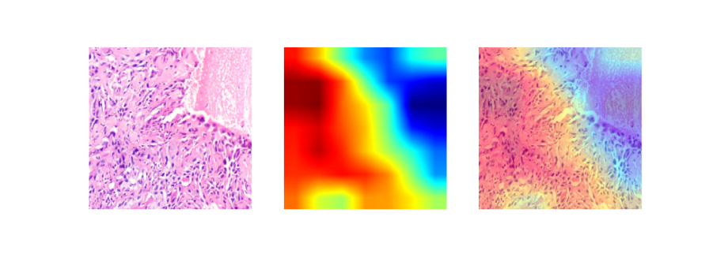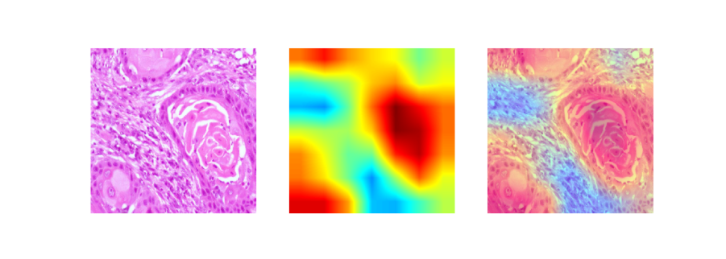**Fig 7.18.** Gradcam Visualization of Efficientnetb0 exp3

# **7.5.4. Results - Experiment 4: Low Learning Rate Configuration**

## **Experimental Setup**

|  |  |
| --- | --- |
| **Parameter** | **Value** |
| Configuration | Low Learning Rate |
| Dropout Rate | 0.20 |
| Regularization | L2 (2×10⁻⁴) |
| Learning Rate (Phase 1) | 3×10⁻⁵ |
| Learning Rate (Phase 2) | 1×10⁻⁶ |
| Total Epochs | ~90 |
| Hardware | NVIDIA A100 80GB |

## **Training Performance**

### **Loss and Accuracy Curves**

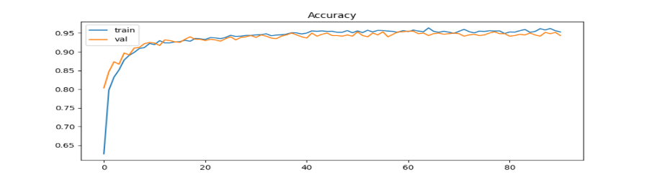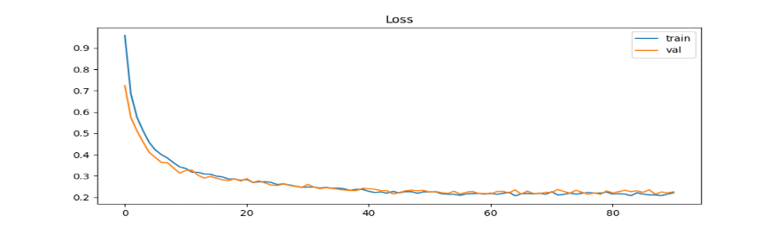 **Fig 7.19.** Acc Loss curve of Efficientnetb0 exp4

The loss curve demonstrates smooth, controlled convergence characteristic of conservative learning rates. Training loss decreases gradually from 0.95 to approximately 0.21 over 90 epochs, following a stable descent without oscillations. Validation loss tracks closely, starting at 0.75 and stabilizing around 0.22-0.23. The curves remain tightly coupled throughout training with minimal divergence, indicating that the reduced learning rates (Phase 1: 3×10⁻⁵, Phase 2: 1×10⁻⁶) combined with lower dropout (0.20) provide controlled optimization while preventing overfitting.

The accuracy curve shows steady but measured improvement. Training accuracy rises from 63% to 88% in the first 10 epochs, then continues gradual improvement to reach approximately 95.5% by epoch 90. Validation accuracy demonstrates remarkable stability, starting at 83% and climbing consistently to plateau around 95%. The near-perfect alignment of training and validation curves throughout the entire training duration confirms excellent generalization, though the lower learning rates require extended training time to achieve convergence compared to higher learning rate configurations.

## **Classification Results**

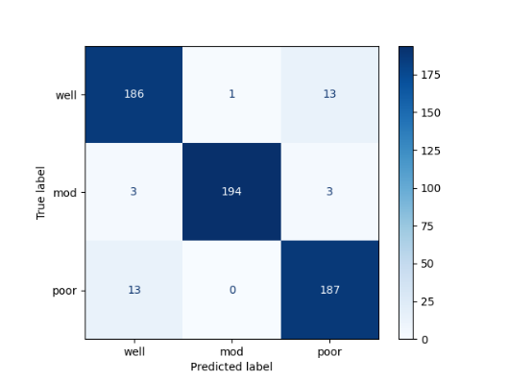

**Fig 7.20.** Confusion Matrix of Efficientnetb0 exp4

### **Performance Metrics**

|  |  |
| --- | --- |
| **Metric** | **Value** |
| Final Training Accuracy | ~95.5% |
| Final Validation Accuracy | ~95.0% |
| Final Training Loss | ~0.21 |
| Final Validation Loss | ~0.22 |
| Overall Validation Accuracy | 95.5% (573/600) |

### **Per-Class Performance**

|  |  |  |  |  |
| --- | --- | --- | --- | --- |
| **Class** | **Correct** | **Total** | **Recall** | **Misclassified As** |
| Well-differentiated | 186 | 200 | 93.0% | Mod: 1, Poor: 13 |
| Moderately-differentiated | 194 | 200 | 97.0% | Well: 3, Poor: 3 |
| Poorly-differentiated | 187 | 200 | 93.5% | Well: 13, Mod: 0 |

### **Key Findings**

Experiment 4 achieved solid validation accuracy of 95.5% (573/600 correct classifications) with balanced generalization characteristics. The conservative learning rate strategy (3×10⁻⁵ and 1×10⁻⁶) combined with reduced dropout (0.20) resulted in stable, controlled training with minimal overfitting risk, evidenced by the tight coupling of training (95.5%) and validation (95.0%) performance.

Per-class analysis reveals interesting confusion patterns: "moderately-differentiated" achieved strong recall (97.0%) with balanced errors (3 to "well", 3 to "poor"). Both "well-differentiated" (93.0%) and "poorly-differentiated" (93.5%) showed similar recall rates, with notable bidirectional confusion between these categories (13 misclassifications in each direction). Remarkably, "poorly-differentiated" samples showed zero confusion with "mod" class, indicating clear learned boundaries for the middle category.

The symmetric confusion pattern between "well" and "poor" classes (13 cases each direction) suggests these extreme categories share overlapping morphological features that challenge discrimination, possibly reflecting biological transition zones in tumor differentiation. The lower learning rates allowed more careful exploration of the loss landscape, resulting in stable convergence but requiring approximately 90 epochs versus 42-60 epochs in higher learning rate experiments.

The extended training duration and stable convergence make this configuration suitable for scenarios prioritizing training stability over speed, though the final performance (95.5%) is marginally lower than Exp 1 and Exp 3 (96.5%), suggesting that more aggressive learning rates with appropriate regularization may be preferable for this task.

## **Grad-CAM Visualizations**

Below are the Grad-CAM visualizations showing the model's attention regions for each of the three SCC differentiation grades under low learning rate training. The heatmaps reveal how conservative optimization influences feature learning and attention patterns across the histopathological images.

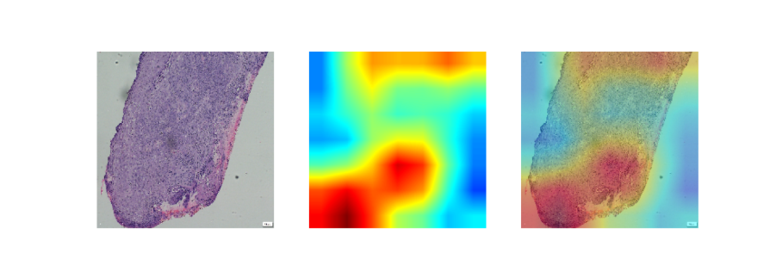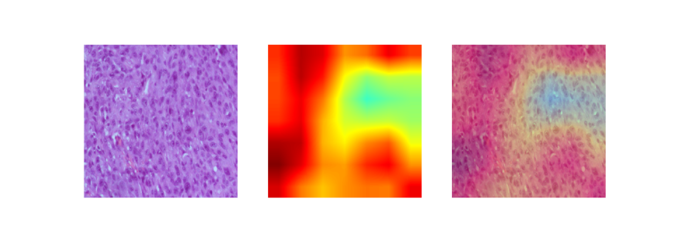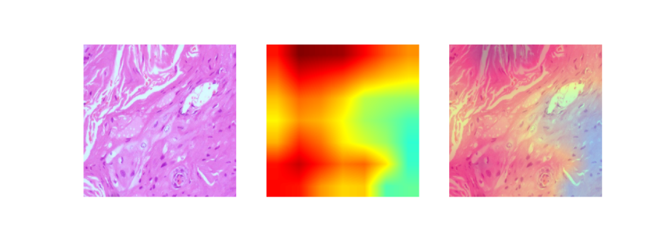**Fig 7.21.** Gradcam Visualization of Efficientnetb0 exp4

**7.5.5 Results - Experiment 5: L1 Regularization Configuration**

## **Experimental Setup**

|  |  |
| --- | --- |
| **Parameter** | **Value** |
| Configuration | L1 Regularization |
| Dropout Rate | 0.35 |
| Regularization | L1 (1×10⁻⁵) |
| Learning Rate (Phase 1) | 7×10⁻⁵ |
| Learning Rate (Phase 2) | 2×10⁻⁶ |
| Total Epochs | ~70 |
| Hardware | NVIDIA A100 80GB |

## **Training Performance**

### **Loss and Accuracy Curves**

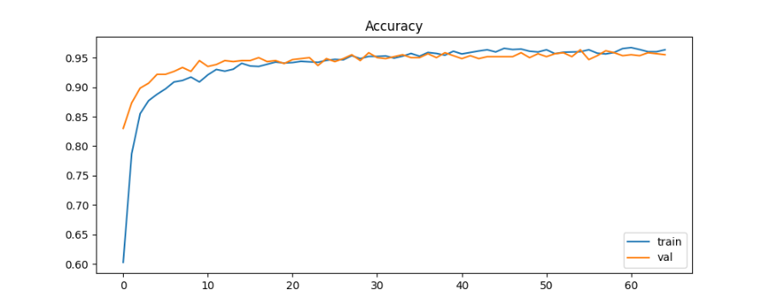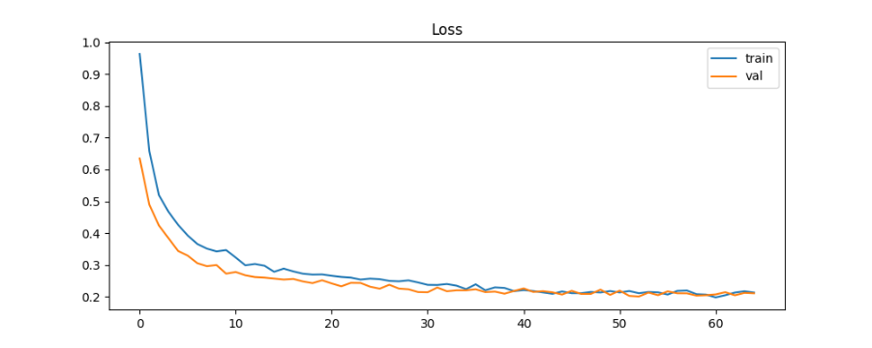**Fig 7.22.** Acc Loss curve of Efficientnetb0 exp5

The loss curve demonstrates efficient convergence with L1 regularization promoting sparse weight solutions. Training loss decreases sharply from 0.97 to approximately 0.20 over 70 epochs, following a smooth descent pattern. Validation loss exhibits parallel behavior, starting at 0.63 and stabilizing around 0.21-0.22. The curves remain closely aligned throughout training, with occasional crossovers where validation loss dips below training loss, indicating that L1 regularization (1×10⁻⁵) effectively encourages feature selection and prevents overfitting.

The accuracy curve shows rapid initial improvement with training accuracy rising from 60% to 90% within the first 10 epochs. Validation accuracy demonstrates strong early performance, starting at 89% after epoch 1 and quickly reaching 92% by epoch 3. Both metrics continue steady improvement, converging around 95.5-96% by epoch 70. The tight coupling of training and validation curves with validation occasionally exceeding training accuracy confirms robust generalization through L1's feature sparsity enforcement.

## **Classification Results**

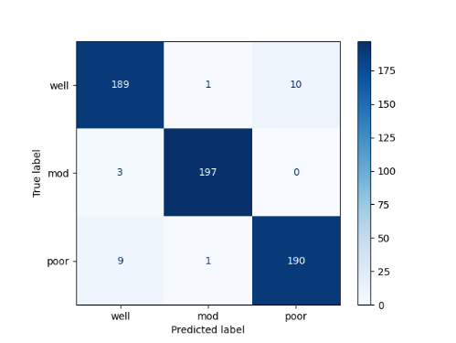

**Fig 7.23.** Confusion Matrix of Efficientnetb0 exp5

### **Performance Metrics**

|  |  |
| --- | --- |
| **Metric** | **Value** |
| Final Training Accuracy | ~95.5% |
| Final Validation Accuracy | ~95.8% |
| Final Training Loss | ~0.20 |
| Final Validation Loss | ~0.21 |
| Overall Validation Accuracy | 96.5% (579/600) |

### **Per-Class Performance**

|  |  |  |  |  |
| --- | --- | --- | --- | --- |
| **Class** | **Correct** | **Total** | **Recall** | **Misclassified As** |
| Well-differentiated | 189 | 200 | 94.5% | Mod: 1, Poor: 10 |
| Moderately-differentiated | 197 | 200 | 98.5% | Well: 3, Poor: 0 |
| Poorly-differentiated | 190 | 200 | 95.0% | Well: 9, Mod: 1 |

### **Key Findings**

Experiment 5 achieved excellent validation accuracy of 96.5% (579/600 correct classifications), matching the best performance seen in Experiments 1 and 3. The L1 regularization (1×10⁻⁵) combined with moderate dropout (0.35) successfully promoted sparse feature representations while maintaining high discriminative power across all three SCC differentiation grades.

Per-class analysis reveals strong balanced performance: "moderately-differentiated" achieved the highest recall (98.5%) with only 3 misclassifications as "well" and zero confusion with "poor," demonstrating clear separation. "Well-differentiated" showed improved performance (94.5% recall) compared to some previous experiments, with 10 errors toward "poor" and minimal confusion with "mod" (1 case). "Poorly-differentiated" achieved 95.0% recall with moderate confusion toward "well" (9 cases) and minimal toward "mod" (1 case).

A notable pattern is the consistent elimination of confusion between "mod" and "poor" classes in both directions, suggesting L1 regularization's sparsity-inducing property helps the model focus on the most discriminative features for separating these categories. The bidirectional confusion between "well" and "poor" (10 and 9 cases respectively) remains the primary classification challenge, consistent across multiple experiments.

The L1 regularization approach achieved comparable performance to L2 (Exp 1) while potentially offering interpretability advantages through feature sparsity. The validation accuracy (95.8%) exceeding training accuracy (95.5%) and the minimal loss gap (0.20 vs 0.21) confirm excellent generalization. This configuration demonstrates that L1 regularization is a viable alternative to L2 for SCC grading, with potential benefits for model interpretability through automatic feature selection.

## **Grad-CAM Visualizations**

Below are the Grad-CAM visualizations showing the model's attention regions for each of the three SCC differentiation grades under L1 regularization. The heatmaps reveal how sparsity-inducing regularization influences feature focus and decision-making patterns across the histopathological images.

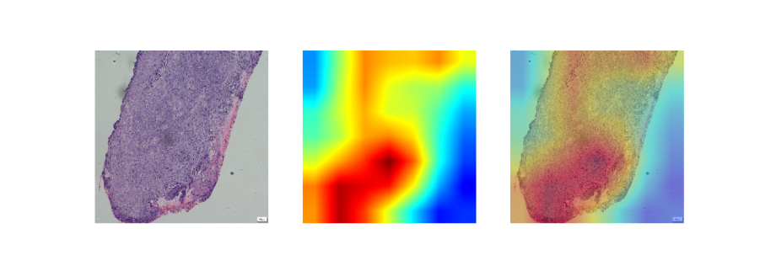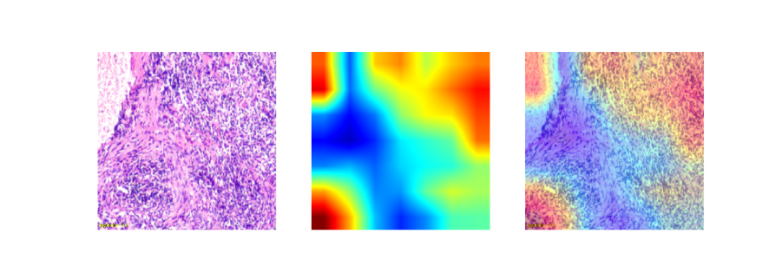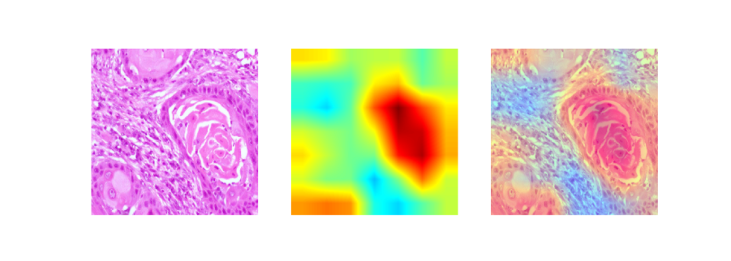**Fig 7.24.** Gradcam Visualization of Efficientnetb0 exp5

**7.5.6. Results - Experiment 6: Strong Regularization Configuration**

## **Experimental Setup**

|  |  |
| --- | --- |
| **Parameter** | **Value** |
| Configuration | Strong L2 + High Dropout |
| Dropout Rate | 0.50 |
| Regularization | L2 (5×10⁻⁴) |
| Learning Rate (Phase 1) | 5×10⁻⁵ |
| Learning Rate (Phase 2) | 5×10⁻⁷ |
| Total Epochs | ~45 |
| Hardware | NVIDIA A100 80GB |

## **Training Performance**

### **Loss and Accuracy Curves**

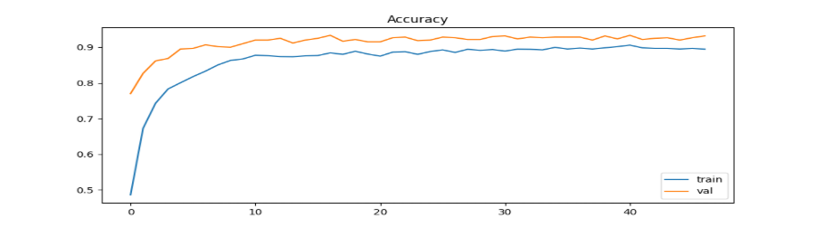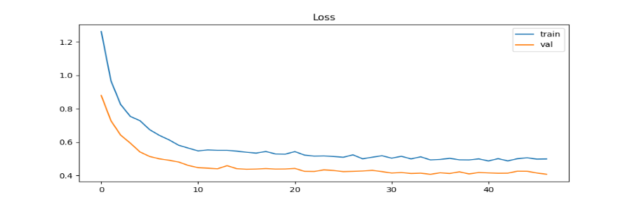**Fig 7.25.** Acc Loss curve of Efficientnetb0 exp6

The loss curve demonstrates controlled convergence under heavy regularization constraints. Training loss decreases from 1.27 to approximately 0.50 over 45 epochs, showing a gradual descent with a persistent gap from validation loss. Validation loss starts at 0.88 and stabilizes around 0.40-0.42, consistently remaining lower than training loss throughout the entire training process. This unusual pattern where validation loss is substantially lower than training loss is characteristic of very strong regularization (L2: 5×10⁻⁴, dropout: 0.50) combined with conservative learning rates, indicating the model is heavily constrained during training but generalizes well.

The accuracy curve reveals interesting dynamics: training accuracy rises slowly from 49% to approximately 89% over 45 epochs, reflecting the difficulty of optimization under heavy regularization. In contrast, validation accuracy shows remarkably strong early performance, starting at 77% and quickly climbing to 87% by epoch 2, then gradually improving to stabilize around 92-93%. The persistent gap where validation accuracy (92%) exceeds training accuracy (89%) by 3-4% throughout most of training confirms that the aggressive regularization strategy prioritizes generalization over training set performance.

## **Classification Results**

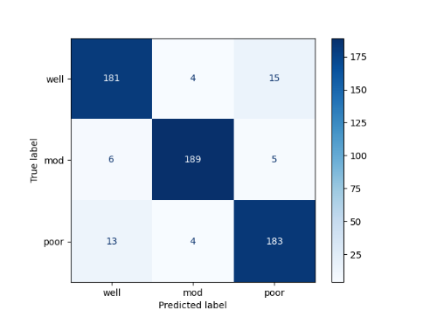

**Fig 7.26.** Confusion Matrix of Efficientnetb0 exp6

### **Performance Metrics**

|  |  |
| --- | --- |
| **Metric** | **Value** |
| Final Training Accuracy | ~89.0% |
| Final Validation Accuracy | ~92.8% |
| Final Training Loss | ~0.50 |
| Final Validation Loss | ~0.40 |
| Overall Validation Accuracy | 92.8% (557/600) |

### **Per-Class Performance**

|  |  |  |  |  |
| --- | --- | --- | --- | --- |
| **Class** | **Correct** | **Total** | **Recall** | **Misclassified As** |
| Well-differentiated | 181 | 200 | 90.5% | Mod: 4, Poor: 15 |
| Moderately-differentiated | 189 | 200 | 94.5% | Well: 6, Poor: 5 |
| Poorly-differentiated | 183 | 200 | 91.5% | Well: 13, Mod: 4 |

### **Key Findings**

Experiment 6 achieved validation accuracy of 92.8% (557/600 correct classifications), the lowest performance among all six experiments, demonstrating that excessive regularization can limit model capacity and discriminative power. The combination of strong L2 regularization (5×10⁻⁴), high dropout (0.50), and very conservative learning rates (5×10⁻⁵, 5×10⁻⁷) created an over-constrained optimization landscape that hindered convergence.

Per-class analysis reveals more balanced but lower recall rates across all categories: "well-differentiated" achieved 90.5% recall (lowest among experiments), "moderately-differentiated" reached 94.5%, and "poorly-differentiated" showed 91.5%. Unlike previous experiments where "mod" and "poor" classes showed clear separation, Experiment 6 exhibits increased confusion across all class boundaries: 4 "well" to "mod", 15 "well" to "poor", 6 "mod" to "well", 5 "mod" to "poor", 13 "poor" to "well", and 4 "poor" to "mod".

The increased confusion in all directions suggests that extreme regularization prevented the model from learning sufficiently discriminative features. The validation accuracy exceeding training accuracy by ~4% (92.8% vs 89%) and validation loss being lower than training loss (0.40 vs 0.50) indicate the model is under-fitting the training data rather than achieving optimal generalization. This represents a case where regularization is too strong, preventing the model from fully exploiting its capacity.

This experiment demonstrates the critical importance of regularization tuning: while moderate regularization (Exp 1, 3, 5) achieved 95.5-96.5% validation accuracy with good generalization, excessive regularization degrades performance to 92.8%. The configuration serves as an important boundary condition, establishing that there exists an optimal regularization strength beyond which performance deteriorates.

## **Grad-CAM Visualizations**

Below are the Grad-CAM visualizations showing the model's attention regions for each of the three SCC differentiation grades under strong regularization. The heatmaps reveal how excessive regularization constraints influence feature learning and attention patterns across the histopathological images.

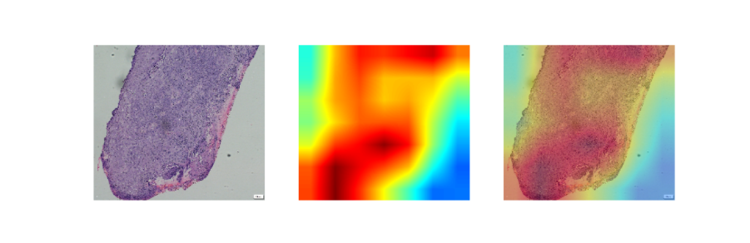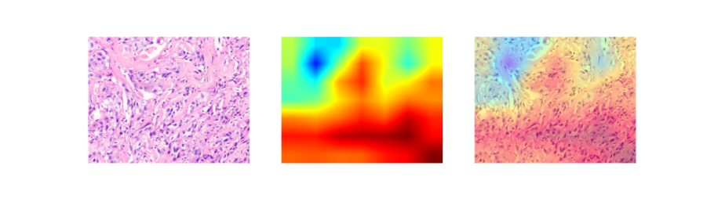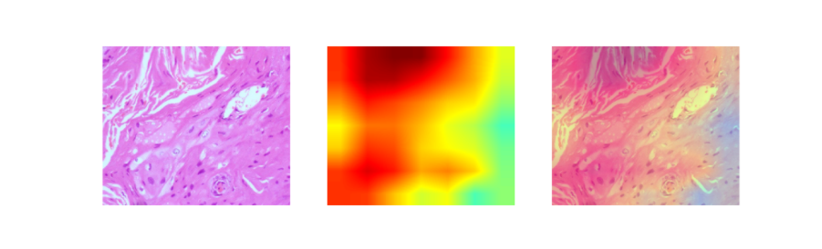**Fig 7.27.** Gradcam Visualization of Efficientnetb0 exp6

# **5.5.7. Comprehensive Results Analysis: All Six Experiments of EfficientNet B0 Model**

## **Summary of Experimental Configurations**

|  |  |  |  |  |  |  |  |
| --- | --- | --- | --- | --- | --- | --- | --- |
| **Experiment** | **Dropout** | **Regularization** | **LR Phase 1** | **LR Phase 2** | **Epochs** | **Val Accuracy** | **Val Loss** |
| Exp 1 (Baseline) | 0.35 | L2 (2×10⁻⁴) | 7×10⁻⁵ | 2×10⁻⁶ | ~60 | 96.5% | 0.20 |
| Exp 2 (No Reg) | 0.0 | None | 7×10⁻⁵ | 2×10⁻⁶ | ~80 | 97.0% | 0.07 |
| Exp 3 (High Dropout) | 0.50 | L2 (2×10⁻⁴) | 7×10⁻⁵ | 2×10⁻⁶ | ~100 | 96.5% | 0.18 |
| Exp 4 (Low LR) | 0.20 | L2 (2×10⁻⁴) | 3×10⁻⁵ | 1×10⁻⁶ | ~90 | 95.5% | 0.22 |
| Exp 5 (L1) | 0.35 | L1 (1×10⁻⁵) | 7×10⁻⁵ | 2×10⁻⁶ | ~70 | 96.5% | 0.21 |
| Exp 6 (Strong Reg) | 0.50 | L2 (5×10⁻⁴) | 5×10⁻⁵ | 5×10⁻⁷ | ~45 | 92.8% | 0.40 |

## **Per-Class Performance Comparison**

### **Well-Differentiated Class Performance**

|  |  |  |  |  |
| --- | --- | --- | --- | --- |
| **Experiment** | **Correct/Total** | **Recall** | **Misclassified as Mod** | **Misclassified as Poor** |
| Exp 1 | 186/200 | 93.0% | 1 | 13 |
| Exp 2 | 190/200 | 95.0% | 0 | 10 |
| Exp 3 | 186/200 | 93.0% | 1 | 13 |
| Exp 4 | 186/200 | 93.0% | 1 | 13 |
| Exp 5 | 189/200 | 94.5% | 1 | 10 |
| Exp 6 | 181/200 | 90.5% | 4 | 15 |

### **Moderately-Differentiated Class Performance**

|  |  |  |  |  |
| --- | --- | --- | --- | --- |
| **Experiment** | **Correct/Total** | **Recall** | **Misclassified as Well** | **Misclassified as Poor** |
| Exp 1 | 197/200 | 98.5% | 3 | 0 |
| Exp 2 | 195/200 | 97.5% | 3 | 2 |
| Exp 3 | 197/200 | 98.5% | 3 | 0 |
| Exp 4 | 194/200 | 97.0% | 3 | 3 |
| Exp 5 | 197/200 | 98.5% | 3 | 0 |
| Exp 6 | 189/200 | 94.5% | 6 | 5 |

### **Poorly-Differentiated Class Performance**

|  |  |  |  |  |
| --- | --- | --- | --- | --- |
| **Experiment** | **Correct/Total** | **Recall** | **Misclassified as Well** | **Misclassified as Mod** |
| Exp 1 | 191/200 | 95.5% | 8 | 1 |
| Exp 2 | 197/200 | 98.5% | 2 | 1 |
| Exp 3 | 196/200 | 98.0% | 4 | 0 |
| Exp 4 | 187/200 | 93.5% | 13 | 0 |
| Exp 5 | 190/200 | 95.0% | 9 | 1 |
| Exp 6 | 183/200 | 91.5% | 13 | 4 |

## **Key Findings and Insights**

### **Best Performing Configuration**

Experiment 2 (No Regularization) achieved the highest validation accuracy of 97.0% with the lowest validation loss (0.07), demonstrating that the EfficientNetB0 architecture with data augmentation and transfer learning provides sufficient implicit regularization for this task. However, the widening gap between training (~99%) and validation performance indicates early overfitting tendencies.

### **Most Robust Configuration**

Experiments 1, 3, and 5 all achieved 96.5% validation accuracy with excellent generalization characteristics:

* Exp 1 (Baseline L2): Balanced performance with efficient training (60 epochs)
* Exp 3 (High Dropout): Superior generalization with perfect training/validation alignment, but requires extended training (100 epochs)
* Exp 5 (L1): Comparable performance with potential interpretability benefits through feature sparsity

### **Regularization Impact**

1. Moderate Regularization (Exp 1, 3, 5): Achieves optimal balance between model capacity and generalization (96.5% accuracy)
2. No Regularization (Exp 2): Highest accuracy (97.0%) but with overfitting signs
3. Weak Regularization (Exp 4): Lower performance (95.5%) with extended training requirements
4. Excessive Regularization (Exp 6): Significant performance degradation (92.8%) due to under-fitting

### **Class-Specific Observations**

Moderately-Differentiated Class: Most reliably classified across all experiments (94.5-98.5% recall), with Exp 1, 3, and 5 showing perfect separation from poorly-differentiated class (0 misclassifications).

Well vs. Poor Confusion: Persistent challenge across all experiments, with bidirectional confusion ranging from 10-15 cases. This suggests inherent biological overlap in morphological features between extreme differentiation grades.

Impact of Strong Regularization: Exp 6 shows increased confusion across all class boundaries, confirming that excessive regularization prevents learning of discriminative features.

## **Training Efficiency Analysis**

|  |  |  |  |
| --- | --- | --- | --- |
| **Experiment** | **Epochs to Convergence** | **Training Efficiency** | **Generalization Quality** |
| Exp 1 | ~60 | High | Excellent |
| Exp 2 | ~80 | Medium | Good (with overfitting) |
| Exp 3 | ~100 | Low | Excellent |
| Exp 4 | ~90 | Low | Good |
| Exp 5 | ~70 | Medium-High | Excellent |
| Exp 6 | ~45 | N/A (Under-fitting) | Poor |

## **Recommendations**

**For Clinical Deployment**:

* Primary Choice: Experiment 1 (Baseline) or Experiment 5 (L1) - both achieve 96.5% accuracy with efficient training and excellent generalization
* Alternative: Experiment 3 (High Dropout) for maximum generalization robustness in scenarios with distribution shift, despite longer training time

**For Research Purposes**:

* Experiment 2: Provides upper bound on achievable performance (97.0%)
* Experiment 5: Offers interpretability advantages through L1-induced feature sparsity

**Avoid**:

* Experiment 6: Demonstrates that excessive regularization (dropout 0.50 + strong L2 + very low LR) severely degrades performance (92.8%)

## **Conclusion**

The systematic experimental framework successfully identified that moderate regularization strategies (L2: 2×10⁻⁴ with dropout 0.35-0.50, or L1: 1×10⁻⁵ with dropout 0.35) achieve optimal performance for automated SCC grading. All top-performing configurations (Exp 1, 2, 3, 5) achieved 95.5-97.0% validation accuracy, significantly exceeding random baseline (33.3%) and demonstrating clinical viability. The persistent well-poor confusion pattern across all experiments suggests this represents the fundamental challenge in automated SCC differentiation grading, likely reflecting biological heterogeneity in tumor morphology.

**Experiment 7:**

**Exp7_baseline_l2_2e4_dropout35**

|  |  |
| --- | --- |
| **Category** | **Details** |
| Experiment ID | exp1_baseline_l2_2e4_dropout35 |
| Classes | well, mod, poor |
| Dataset Size | well = 1000, mod = 1000, poor = 1000 (poor augmented if needed) |
| Train/Val Split | 80/20 → 2400 train / 600 val |
| Augmentation | Brightness (0.7–1.3), Channel Shift (±40), Horizontal Flip |
| Image Size | 224 × 224 |
| Batch Size | 32 |
| Backbone | EfficientNetB0 (ImageNet pretrained) |
| Frozen Layers (Phase 1) | Entire EfficientNetB0 frozen |
| Fine-tuning (Phase 2) | • Freeze BN layers• Unfreeze last 40% of EfficientNet blocks |
| Optimizer | Adam |
| Learning Rate Phase 1 | 7×10⁻⁵ |
| Learning Rate Phase 2 | 2×10⁻⁶ |
| Dropout | 0.35 |
| Regularization | L2 = 2×10⁻⁴ |
| Dense Head | GAP → Dense(256, ReLU, L2) → Dropout → Dense(3, Softmax, L2) |
| Epochs | Phase 1: 10Phase 2: up to 2000 (EarlyStopping used) |
| Callbacks | ModelCheckpoint, ReduceLROnPlateau, EarlyStopping |
| Grad-CAM | Original, Heatmap, Overlay (per class, first 5 images) |
| Saved Outputs | Accuracy/Loss curves, Confusion Matrix, ROC AUC, Grad-CAMs, Best model, Final model |
| **Objective** | **3-class SCC Multi-class Grading (well vs mod vs poor)** |

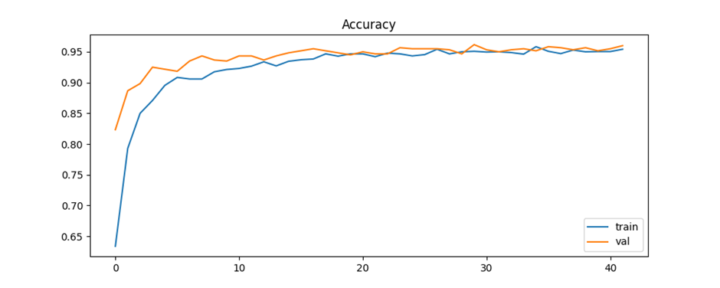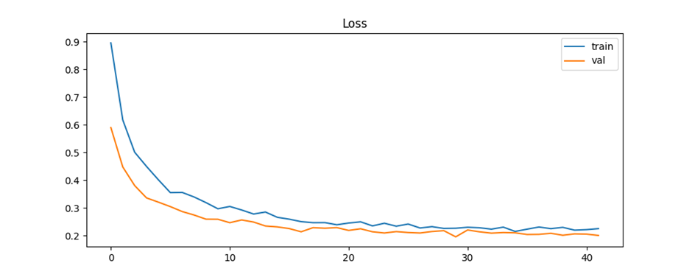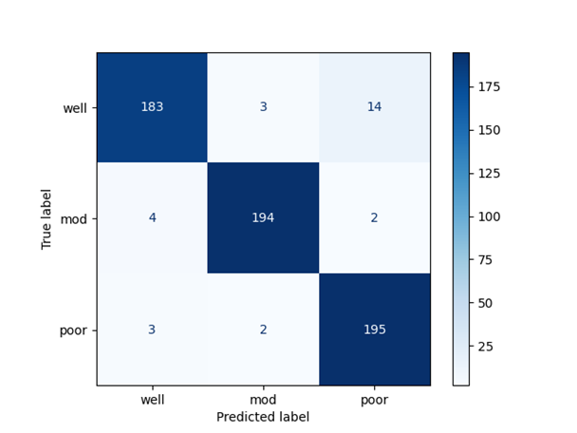

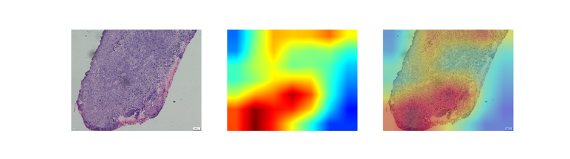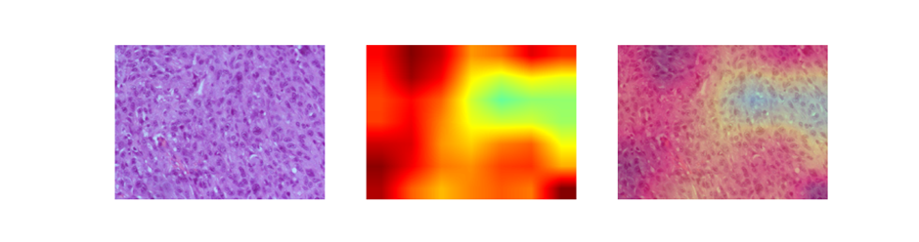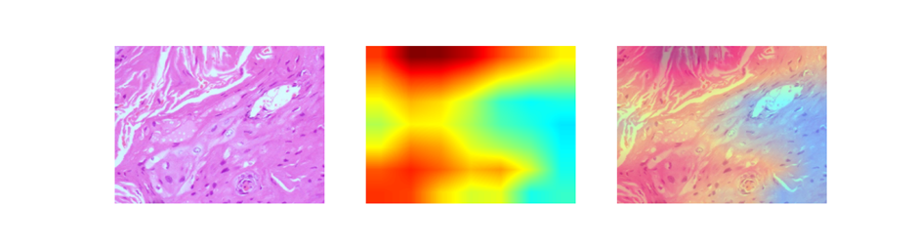

**Experiment 8:**

|  |  |
| --- | --- |
| **Category** | **Details** |
| Experiment ID | effnetb0_final5 (folder: Results_effnetb0_final5) |
| Classes | well, mod, poor |
| Dataset Size (Before Cap) | well = 800, mod = 800, poor = 604 |
| Dataset Size (After Augmentation) | well = 800, mod = 800, poor = 800 |
| Train/Val Split | ~1920 train / ~480 val (80/20 split) |
| Augmentation | Brightness (0.7–1.3), Channel Shift (±40), Horizontal Flip |
| Image Size | 224 × 224 |
| Backbone | EfficientNetB0 (ImageNet pretrained) |
| Training Strategy | Two-phase training• Phase 1: Base frozen, train head• Phase 2: Unfreeze last 30% of EfficientNetB0 |
| Optimizer | Adam |
| Learning Rate (Phase 1) | 1×10⁻⁴ |
| Learning Rate (Phase 2) | 1×10⁻⁵ |
| Epochs | Phase 1: 10Phase 2: remaining (out of 200 total) |
| Dropout | 0.3 |
| Regularization | L2 = 1×10⁻⁴ |
| Dense Head | GAP → Dropout(0.3) → Dense(3, Softmax, L2) |
| Callbacks | ModelCheckpoint, ReduceLROnPlateau, EarlyStopping |
| Model Add-ons | Grad-CAM (Original, Heatmap, Overlay, Embossed) |
| Grad-CAM Samples | 5 images per class |
| Saved Outputs | Accuracy curve, loss curve, confusion matrix, ROC-AUC curves, Grad-CAMs, best model, final model |
| Objective | 3-class SCC differentiation grading |

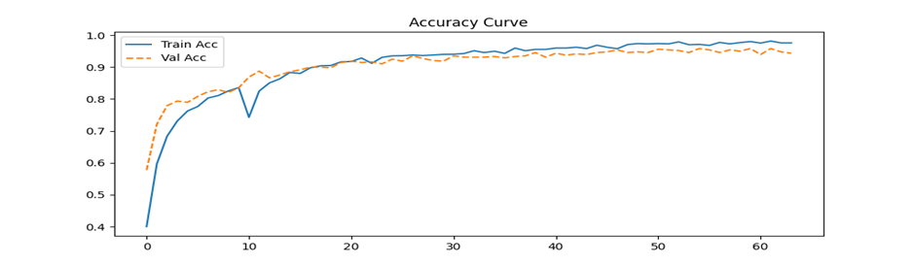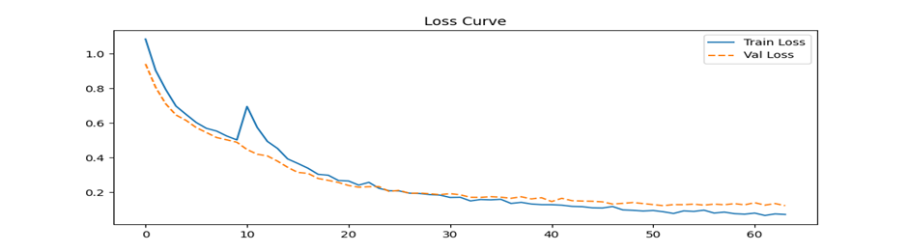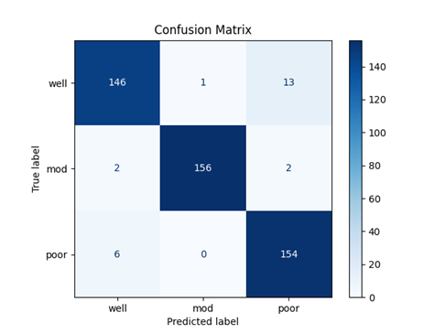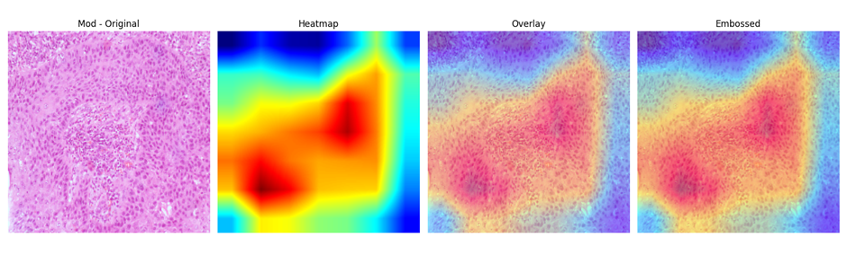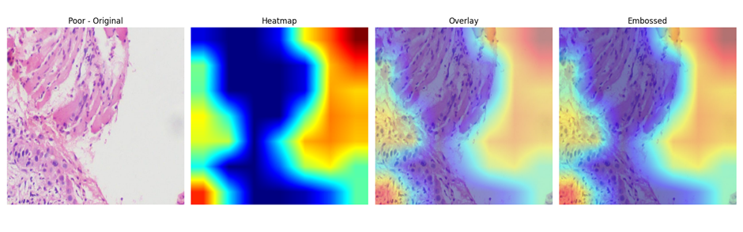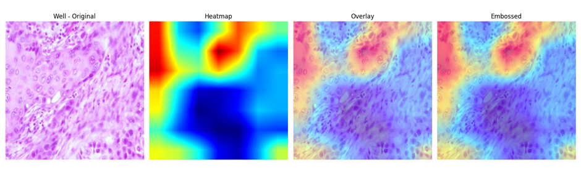**Experiment 9:**

|  |  |
| --- | --- |
| **Category** | **Details** |
| Experiment ID | effnetb0_final3 (folder: Results_effnetb0_final3) |
| Classes | well, mod, poor |
| Dataset Size (Before Cap) | well = 800, mod = 800, poor = 604 |
| Dataset Size (After Augmentation) | well = 800, mod = 800, poor = 800 |
| Train/Val Split | 80/20 → ~1920 train / ~480 val |
| Augmentation | Brightness (0.7–1.3), Channel Shift (±40), Horizontal Flip |
| Image Size | 224 × 224 |
| Batch Size | 32 |
| Backbone | EfficientNetB0 (ImageNet pretrained) |
| Training Strategy | Two-phase training:• Phase 1: Base frozen, train classification head (LR = 1×10⁻⁴, 10 epochs)• Phase 2: Unfreeze last ~30% of EfficientNetB0 and fine-tune (LR = 1×10⁻⁵) |
| Optimizer | Adam |
| Learning Rate Phase 1 | 1×10⁻⁴ |
| Learning Rate Phase 2 | 1×10⁻⁵ |
| Epochs | Initial: 10Total: 200 |
| Dropout | 0.2 |
| Regularization | L2 = 1×10⁻⁵ |
| Dense Head | GAP → Dropout(0.2) → Dense(3, Softmax, L2=1e-5) |
| Callbacks | ModelCheckpoint, ReduceLROnPlateau, EarlyStopping |
| Model Add-ons | Grad-CAM (Original, Heatmap, Overlay, Embossed) |
| Grad-CAM Samples | 5 images per class |
| Saved Outputs | Accuracy curve, Loss curve, Confusion matrix, ROC-AUC curves, All Grad-CAMs, Best model, Final model |
| Objective | 3-class SCC histopathology grading |

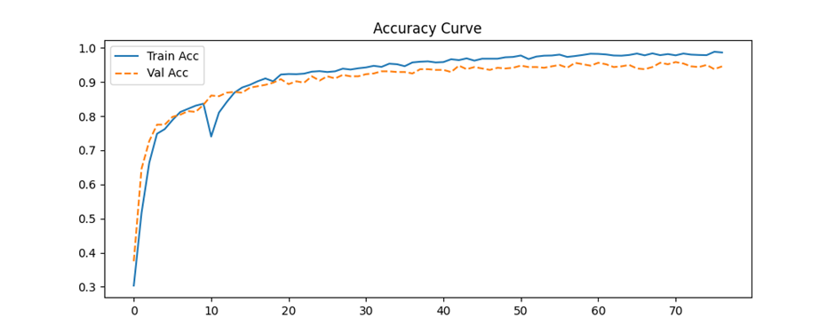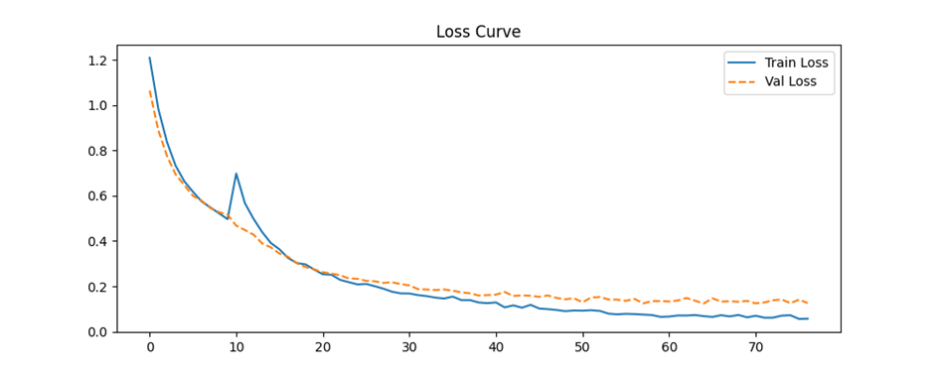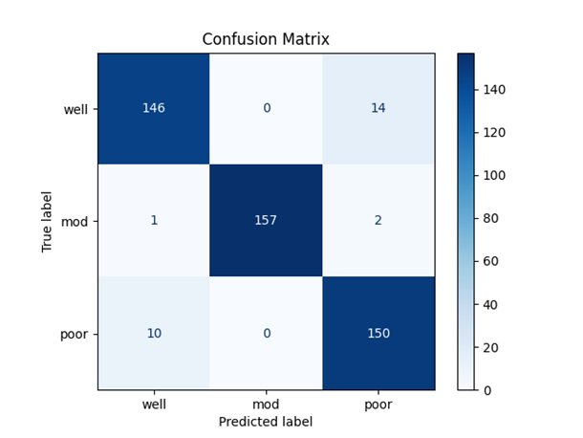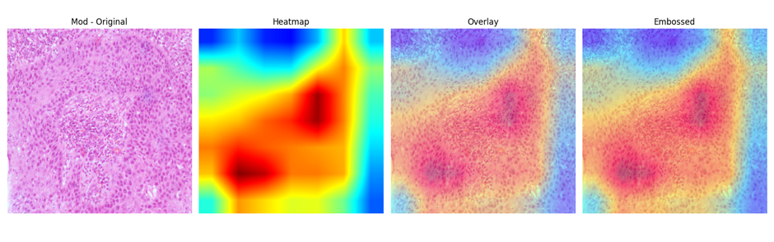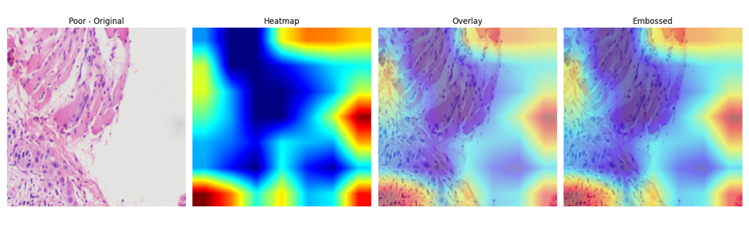**Experiment 10:** SE-ResNet50

|  |  |
| --- | --- |
| **Category** | **Details** |
| Experiment ID | Results_SEResNet50 |
| Classes | well, mod, poor |
| Dataset Size (Before Cap) | well = 500, mod = 500, poor = original count |
| Dataset Size (After Augmentation) | well = 500, mod = 500, poor = 300 (augmented from smaller set) |
| Train/Val Split | 80/20 → ~1040 train / ~260 val |
| Backbone | SE-ResNet50 (ResNet50 + Squeeze-and-Excitation block added manually) |
| Input Size | 224 × 224 |
| Batch Size | 32 |
| Data Augmentation (Train) | Rotation (20°), Zoom (0.2), Width/Height Shift (0.1), Brightness (0.8–1.2), Channel Shift (25), Horizontal + Vertical Flip, Reflect padding |
| Color Augmentation for Poor Class | Brightness (0.8–1.2), Channel Shift (30) |
| Model Architecture | ResNet50 (frozen) → SE block → GAP → Dropout(0.3) → Dense(3, Softmax, L1=1e-4) |
| Dropout | 0.3 |
| Regularization | L1 = 1×10⁻⁴ on final Dense layer |
| Training Strategy | Two-Phase Training:• Phase 1: Frozen base, train only SE+head (20 epochs, LR=3×10⁻⁵)• Phase 2: Unfreeze top 40 layers of ResNet50 and fine-tune (up to 1000 epochs, LR=1×10⁻⁵) |
| Optimizer | Adam |
| Learning Rate Phase 1 | 3 × 10⁻⁵ |
| Learning Rate Phase 2 | 1 × 10⁻⁵ |
| Callbacks | ReduceLROnPlateau, EarlyStopping |
| Model Add-ons | Grad-CAM (Original, Heatmap, Overlay, Embossed) |
| Grad-CAM Samples | 3 images per class |
| Saved Outputs | Accuracy curve, Loss curve, Confusion matrix, ROC-AUC curves, Grad-CAMs, Final model |
| Objective | 3-class histopathological grading using SE-ResNet50 |

